
INDUSTRY REPORT
Global Ship & Boat Building
Apr 2026

About

IBISWorld
IBISWorld specializes in industry research with coverage on thousands of global industries. Our comprehensive data and in-depth analysis help businesses of all types gain quick and actionable insights on industries around the world. Busy professionals can spend less time researching and preparing for meetings, and more time focused on making strategic business decisions.

Table Of Contents | Standard

1. About 4
Codes 4
Definition 4
Related Terms 4
What's Included 4
Companies 5
Related Industries 5
Additional Resources 5
2. At a Glance 6
Key Takeaways 6
Products and Services 7
Major Players 8
Key External Drivers 9
Industry Structure 9
SWOT 10
Executive Summary 10
3. Performance 11
Highlights 11
Key Takeaways 11
Performance Snapshot 12
Outlook 21
Life Cycle 24
4. Products and Markets 25
Key Takeaways 25
Products and Services 25
Major Markets 29
International Trade 31
Imports 34
Exports 35
5. Geographic Breakdown 36
Key Takeaways 36
Business Locations 37
6. Competitive Forces 41
Key Takeaways 41
Concentration 41
Barriers to Entry 43
Substitutes 44
Buyer & Supplier Power 46
7. Companies 48
Key Takeaways 48
Market Share 49
Companies 50
8. External Environment 53
Key Takeaways 53
External Drivers 53
Regulation & Policy 56
Assistance 58
9. Financial Benchmarks 59
Key Takeaways 59
Cost Structure 59
Key Ratios 62
10. Key Statistics 64
Industry Data 64

1. About
https://my.ibisworld.com/gl/en/industry/C2541-GL/about

Codes
ISIC Rev. 4 | 3011

Definition
This industry encompasses the construction of commercial vessels, warships, fishing boats, floating structures like docks and platforms and hovercraft (excluding recreational types). Maintenance, repair of ships and ship-breaking are excluded from this industry.

Related Terms

DEADWEIGHT TONS (DWT)
An expression of a ship's carrying capacity, including the weight of the crew, passengers, cargo, fuel, ballast, drinking water and stores.

COMPENSATED GROSS TONNAGE (CGT)
An expression of the amount of necessary labor to produce a ship based on its size, weight and type.

TRANSOM
The surface that forms the stern (rear) of a vessel.

TWENTY-FOOT EQUIVALENT UNIT (TEU)
A measure used in intermodal transport.

ORDER BOOK
Ship and boat builders often have considerable volumes of orders under construction, or awaiting construction. A large order book insulates a company from peaks and troughs in the market.

What's Included
- Building barges
- Building cargo ships
- Building container ships
- Building passenger ships
- Repairing ships
- Converting and altering ships
- Producing prefabricated ship and barge sections
- Providing specialized ship services

Companies
- Korea Shipbuilding & Offshore Engineering Co. Ltd.

Related Industries

Industries in the Same Sector
- Competitors:
  - Global Cargo Airlines
  - Global Logistics - Rail Transport
  - Global Heavy-Duty Truck Manufacturing
- Complementors:
  - Global Oil & Gas Exploration & Production
  - Global Deep-Sea, Coastal & Inland Water Transportation
  - Global Marine & Container Terminal Operation

International Industries
- Ship Building in the US
- Boat Building in the US
- Boat Dealership and Repair in the US
- Autonomous Underwater Vehicle Manufacturing in the US
- Ship Building in Canada
- Boat Building in Canada
- Shipbuilding and Repair Services in Australia
- Boatbuilding and Repair Services in Australia
- Shipbuilding and Repair Services in New Zealand
- Boatbuilding and Repair Services in New Zealand
- Shipbuilding in the UK
- Recreational Boat & Yacht Building in the UK
- Boat Repair & Maintenance in the UK
- Ship Building in China
- Ship Repairing and Conversion in China

Additional Resources
- UN Comtrade
- Shipyards’ & Maritime Equipment Association
- Maritime Intelligence | Informa

2. At a Glance
https://my.ibisworld.com/gl/en/industry/C2541-GL/at-a-glance
Revenue  $223.9bn  ’21-’26 ↑ 0.8 %  ’26-’31 ↑ 1.9 % | Employees  566k  ’21-’26 ↓ 2.1 %  ’26-’31 ↑ 1.1 % | Businesses  3,773  ’21-’26 ↑ 4.1 %  ’26-’31 ↑ 1.1 %
Profit  $15.0bn  ’21-’26 ↓ 0.9 % | Profit Margin  6.7%  ’21-’26 ↓ 0.6 pp | Wages  $51.4bn  ’21-’26 ↓ 3.3 %  ’26-’31 ↑ 1.2 %

Key Takeaways

Performance
- China’s shipbuilding capacity has grown substantially due to government support. Government subsidies, favorable lending and modern yard infrastructure continue to support China's dominant market position, though growing scrutiny of Chinese-built vessels by US buyers has redirected some orders to South Korea.
- The US shipbuilding industry benefits from extensive defense contracts. The Department of Defense’s consistent funding helps ensure a steady workload for shipyards.
- Global competition drives shipbuilding industry consolidation. Small firms struggle to compete against larger international players, prompting mergers. Technological advancements and high R&D costs favor larger, consolidated companies.

Products and Markets
- In June 2025, the US enforced a 50.0% tariff on steel and aluminum imports. This move potentially boosts non-US shipbuilders by reducing material expenses for components like hulls and frames, as suppliers will have more inventory available because of potential decreased US interest in these materials.
- Geopolitical tensions and defense budgets influence demand for military vessels. Nations bolster naval fleets to enhance national security and global power projection. Regular upgrades and replacements are vital for maintaining fleet readiness and efficiency.
- Economic growth and international trade boost demand for commercial vessels. Growing trade requires more container ships, bulk carriers and tankers, while older vessels need to be replaced.

Products and Services
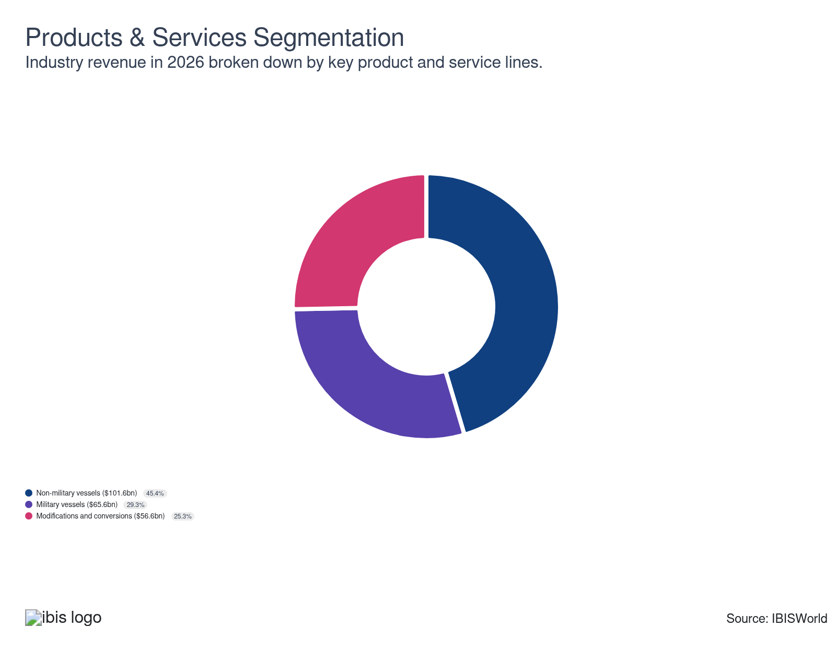

Major Players
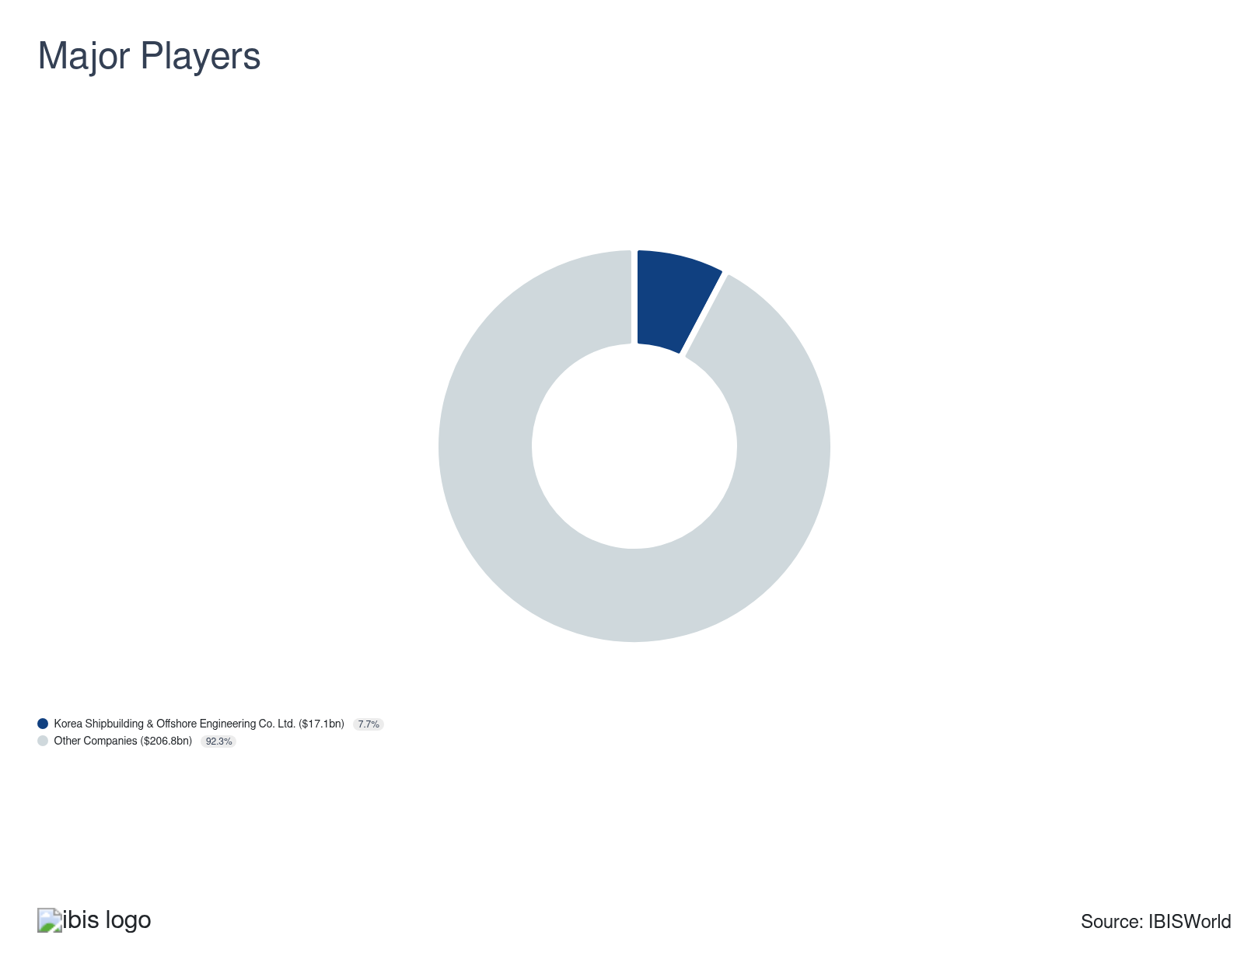

Key External Drivers
Key External Drivers | Impact
Total value of world trade | Positive
World price of steel | Positive
Global consumer spending | Positive
Industrial production index of OECD countries | Positive

Industry Structure
Characteristic | Level | Trend
Concentration | Low
Barriers To Entry | High | Steady
Regulation and Policy | Moderate | Steady
Life Cycle | Mature
Revenue Volatility | Low
Assistance | High | Steady
Competition | High | Steady
Innovation | Moderate

SWOT
Strengths  Low Volatility  Low Customer Class Concentration  Low Product/Service Concentration  High Revenue per Employee | Weaknesses  Low Profit vs. Sector Average  High Capital Requirements | Opportunities  High Revenue Growth (2020-2025)  High Revenue Growth (2025-2030)  High Performance Drivers  Global consumer spending | Threats  Low Outlier Growth  World price of steel

Executive Summary

On the rise: China's shipbuilding capacity soars with robust government funding
China has cemented its position as the world's dominant shipbuilder, capturing the majority of global new orders in 2026. The country has leveraged government subsidies to modernize its shipyards and bolstered its technological capabilities. This has enabled Chinese shipbuilders to expand production volumes to compete for international contracts, especially in high-value segments such as LNG carriers and cruise ships. While other North Asian powerhouses like South Korea and Japan remain competitive, they continue to face more pressure from China's rapid expansion and lower production costs. Global shipbuilding has remained mostly steady, growing at a CAGR of 0.8% through 2026, reaching $223.9 billion, including a 1.5% uptick in 2026 alone. Profit has narrowed from 7.3% of revenue in 2021 to an estimated 6.7% in 2026, squeezed by volatile steel prices and rising costs on fixed-price defense contracts.
Another pivotal trend is the industry's move towards consolidation and technological advancements. Intense global competition and the rising demand for specialized, technologically advanced vessels have pushed many smaller firms to merge with larger entities, resulting in fewer but more robust players in the market. Innovations in materials and automation technology have also revolutionized the shipbuilding process. The use of corrosion-resistant alloys and composites has improved vessel durability and fuel efficiency, while automation and digitalization, including robotic welding and automated assembly lines, have bolstered production efficiency and reduced cost, setting new industry standards.
The product mix is shifting as environmental regulations tighten and geopolitical disruptions reshape trade routes. Alternative-fuel-capable vessels now account for 50.0% of the global order book, according to the OECD, more than double the share a decade ago. The conflict between the United States and Iran, which escalated in late February 2026, has disrupted shipping through the Strait of Hormuz and strained existing fleet capacity, while US tariffs on steel and aluminum imports have added further volatility to input costs for builders worldwide.
Defense spending and fleet renewal are expected to anchor demand in the coming years. The Pentagon's fiscal year 2027 budget request includes a significant increase in shipbuilding funding and several allied nations are reassessing naval fleet requirements in response to heightened maritime security concerns. Tightening emissions standards will continue to push shipowners toward new construction and vessel modifications, supporting both the non-military vessel and modifications segments. Global shipbuilding revenue is expected to grow at a CAGR of 1.9%, reaching an estimated $246.0 billion by 2031.

3. Performance
https://my.ibisworld.com/gl/en/industry/C2541-GL/performance

Highlights
Revenue  $223.9bn  2021-26 CAGR ↑ 0.8 %  2026-31 CAGR ↑ 1.9 % | Employees  566k  2021-26 CAGR ↓ 2.1 %  2026-31 CAGR ↑ 1.1 % | Businesses  3,773  2021-26 CAGR ↑ 4.1 %  2026-31 CAGR ↑ 1.1 %
Profit  $15.0bn  2021-26 CAGR ↓ 0.9 % | Profit Margin  6.7%  2021-26 CAGR ↓ 0.6 pp

Key Takeaways
- China’s shipbuilding capacity has grown substantially due to government support. Government subsidies, favorable lending and modern yard infrastructure continue to support China's dominant market position, though growing scrutiny of Chinese-built vessels by US buyers has redirected some orders to South Korea.
- The US shipbuilding industry benefits from extensive defense contracts. The Department of Defense’s consistent funding helps ensure a steady workload for shipyards.
- Global competition drives shipbuilding industry consolidation. Small firms struggle to compete against larger international players, prompting mergers. Technological advancements and high R&D costs favor larger, consolidated companies.

Performance Snapshot
Revenue: | ↑ 2021-26 Revenue CAGR +0.8%
Revenue  $223.9bn  ’21-’26 ↑ 0.8 %  ’26-’31 ↑ 1.9 % | 2026 Revenue Growth  ↑ 1.5 % | Revenue Volatility  Low
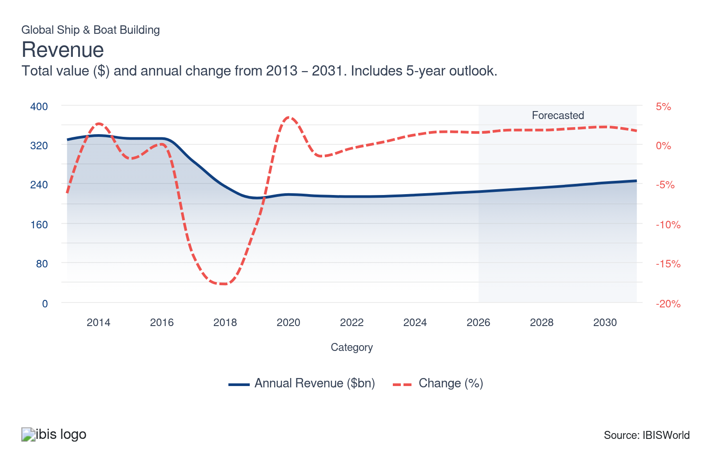
Employees: | ↓ 2021-26 Employees CAGR -2.1%
Employees  566k  ’21-’26 ↓ 2.1 %  ’26-’31 ↑ 1.1 % | Employees per Business  150  ’21-’26 ↓ 6.0 %  ’26-’31 ↓ 0.0 % | Revenue per Employee  $396k  ’21-’26 ↑ 3.0 %  ’26-’31 ↑ 0.8 %
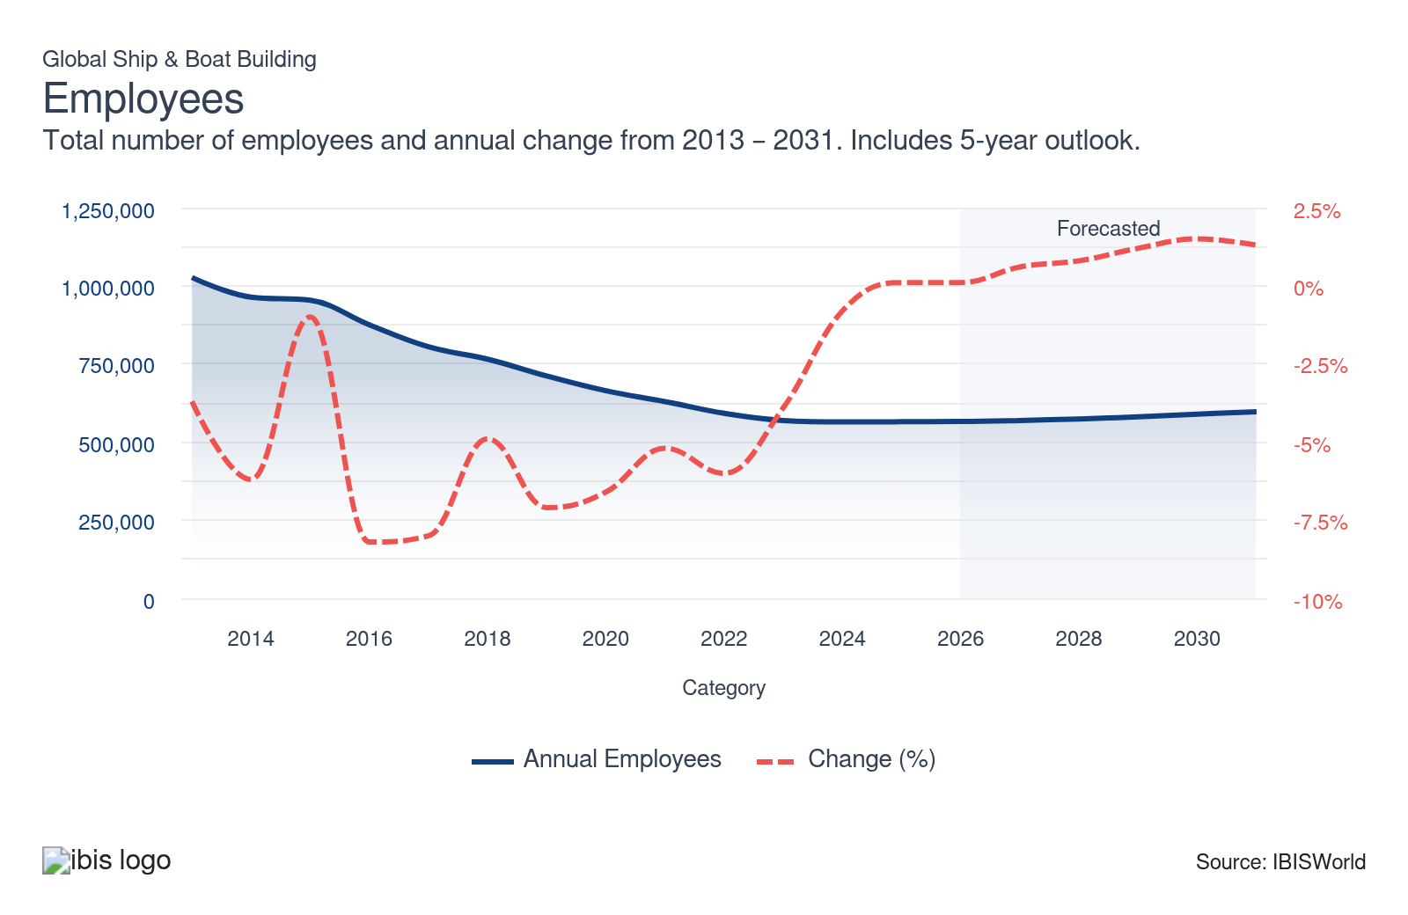
Businesses: | ↑ 2021-26 Business CAGR +4.1%
Businesses  3,773  ’21-’26 ↑ 4.1 %  ’26-’31 ↑ 1.1 % | Employees per Business  150  ’21-’26 ↓ 6.0 %  ’26-’31 ↓ 0.0 % | Revenue per Business  $59.3m  ’21-’26 ↓ 3.2 %  ’26-’31 ↑ 0.8 %
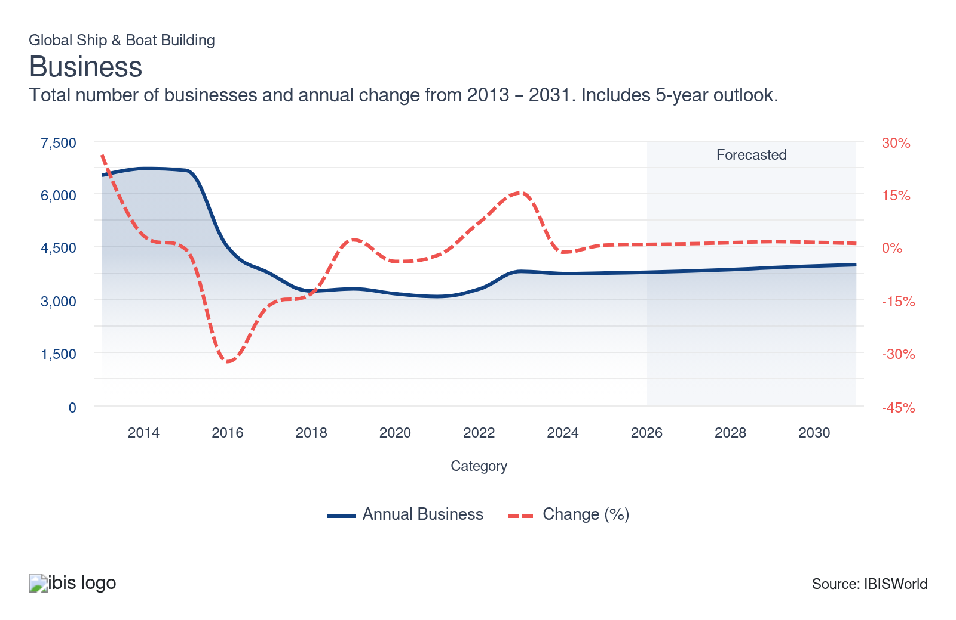
Profit: | ↓ 2021-26 Profit CAGR -0.9%
Total Profit  $15.0bn  ’21-’26 ↓ 0.9 % | Profit Margin  6.7%  ’21-’26 ↓ 0.6 pp | Profit per Business  $4.0m
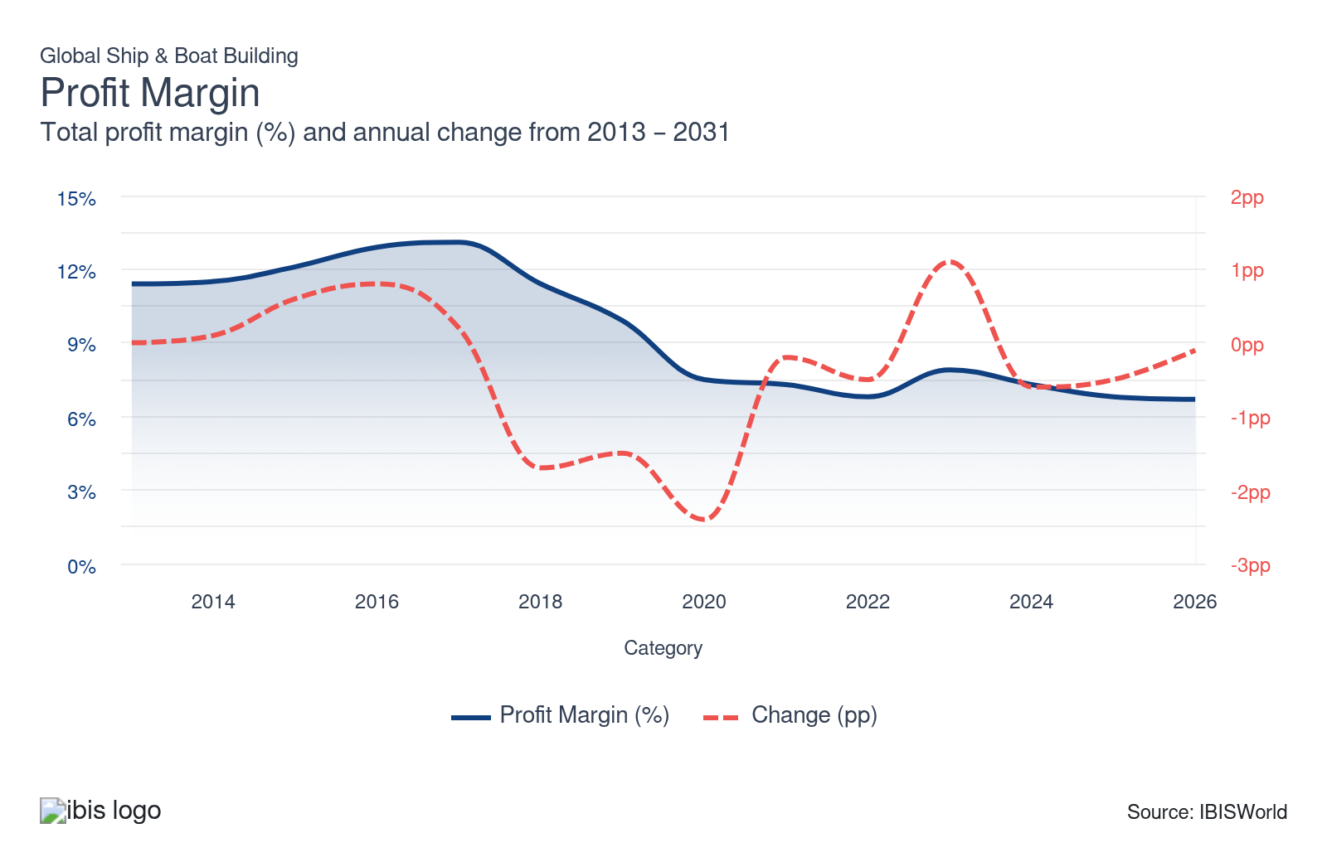
Current Performance
Current Performance

What's driving current industry performance?

China's shipbuilding dominance continues to grow with robust government backing
- The Chinese government's strategic industrial policies have accelerated the country's rise as the world's dominant shipbuilder. Through subsidies, favorable lending and long-term plans that prioritize the maritime sector, the Chinese government has reduced production costs and encouraged investment in modern shipyard infrastructure. According to Clarkson Research, China now accounts for over half of global shipbuilding orders by compensated gross tonnage, which weights each ship by build size and complexity rather than just by size.
- China's military-civil fusion strategy has further strengthened its shipbuilding base. By integrating commercial and naval shipbuilding operations at shared facilities, Chinese builders can spread fixed costs across a wider order book and channel commercial innovations into military programs. This approach gives China a structural cost advantage that competitors in South Korea and Japan struggle to replicate, particularly for high-volume vessel categories.
- In April 2026, CANSI reported a string of new international orders at China State Shipbuilding Corporation (CSSC) yards, including two Suezmax crude oil tankers — vessels sized to transit the Suez Canal fully loaded — for Greek firm Venergy Maritime, and a 319,000-deadweight-ton very large crude carrier with ammonia-fuel provisions for South Korean shipowner Pan Ocean. The ammonia-ready design allows the vessel to be retrofitted for cleaner fuel as the technology matures, positioning the buyer to meet tightening IMO emissions standards without ordering a second ship. These contracts reflect growing international confidence in Chinese yards for both conventional and next-generation vessel construction.
- The CSSC, which became the world's largest shipbuilder after its 2019 merger with China Shipbuilding Industry Corporation, continues to leverage its scale to compete aggressively for international contracts. The combined entity's resource optimization and shipyard capacity have made it a go-to builder for foreign shipping companies looking to lock in competitive pricing.

The conflict between the US and Iran is disrupting global shipping lanes and reshaping demand
- The conflict between the US and Iran that began in late February 2026 has caused significant disruption to maritime trade through the Strait of Hormuz. The strait had previously handled an estimated 25.0% of the world's seaborne oil trade and 20.0% of global LNG shipments, according to the Congressional Research Service. Passage through the waterway has reportedly been restricted since early March 2026, and several major shipping firms have suspended operations in the area.
- The disruption is reshaping operating conditions for the maritime industry. Shipping companies rerouting vessels around the Cape of Good Hope face longer transit times and higher operating costs, which may strain existing fleet capacity over time. Insurance premiums for vessels operating near the Persian Gulf have risen sharply, adding to the total cost of maritime operations. Higher oil prices — with Brent crude peaking at over $100 per barrel in March 2026 — have also raised energy and material costs for shipbuilders that rely on energy-intensive production processes.
- The conflict has added uncertainty to defense procurement planning across multiple countries. The Pentagon's fiscal year 2027 budget request, released in April 2026, includes a significant increase in shipbuilding funding, according to USNI News. Several allied nations in Europe and Asia are also reassessing their naval fleet requirements in response to the disruption of a critical maritime chokepoint, though the scale and timing of any additional orders remain unclear.
- The full effect on the global shipbuilding industry depends on the duration and resolution of the conflict. Prolonged disruption to the Strait of Hormuz could continue to elevate input costs for shipbuilders while also adding pressure on shipping companies to reassess fleet planning. However, the uncertain environment may also cause some buyers to delay placing new orders until conditions stabilize.

Consolidation among major shipbuilders is intensifying global competition
- The trend toward consolidation in shipbuilding has accelerated, driven by the need for scale to compete with China's subsidized yards and to meet growing demand for technologically advanced vessels. In December 2025, South Korea's HD Hyundai Heavy Industries completed its merger with HD Hyundai Mipo Dockyard in a deal valued at $5.5 billion, according to HD Korea Shipbuilding & Offshore Engineering. The combined entity now operates as a unified HD Hyundai Heavy Industries with expanded capacity across both large-scale and mid-sized vessel construction.
- The merger was motivated in part by the Make American Shipbuilding Great Again (MASGA) initiative, a bilateral cooperation framework between South Korea and the United States aimed at revitalizing US shipyard capacity. HD Hyundai has targeted $7.2 billion in annual defense-related revenue by 2035, with the combined shipyard infrastructure from Mipo giving it dedicated capacity for military vessel production. The company is also expanding overseas through yards in Vietnam and the Philippines.
- These moves mirror China's earlier consolidation through CSSC and Japan's own merger activity among its top builders. In the global market, fewer but larger players mean sharper competition for high-value contracts — particularly for LNG carriers, naval combatants and specialized offshore vessels — while smaller yards face growing pressure to find niches or exit the market.

US tariffs on steel and aluminum are raising costs for shipbuilders worldwide
- US tariffs on steel and aluminum imports have escalated significantly and now represent a material cost factor for shipbuilders sourcing materials from or selling to the US market. The tariffs, originally set at 25.0% in March 2025 under Section 232, were raised to 50.0% in June 2025. In April 2026, the tariff structure was further revised to apply to the full customs value of imported products, including derivative articles containing steel, aluminum and copper.
- Steel is the largest raw material input for shipbuilders, used in hulls, frames, armor and structural components. For US-based shipbuilders, the tariffs have raised domestic steel prices and constrained sourcing options. Senator Tim Kaine of Virginia highlighted that an estimated 35.0% of materials used in US naval shipbuilding are sourced from allied nations, including the United Kingdom, Canada and European countries, according to the Senate Armed Services Committee. Higher input costs are squeezing profit margin on fixed-price defense contracts and have contributed to delays on programs already running behind schedule.
- For non-US shipbuilders, the tariffs have an indirect effect. Excess steel and aluminum inventory that would have been exported to the US is now available on global markets, potentially lowering input costs for international yards. However, broader trade uncertainty and retaliatory tariffs from countries such as Canada and the European Union have disrupted global supply chains and added volatility to commodity prices. Purchases account for an estimated almost half of industry revenue in 2026, making input cost management critical to profitability.

Demand for LNG carriers and alternative-fuel vessels is transforming the product mix
- The non-military vessel segment is being reshaped by the transition toward alternative fuels and stricter environmental regulations. The International Maritime Organization's (IMO) decarbonization targets and the 2020 Sulfur Cap have pushed shipowners to order vessels capable of running on LNG, methanol or hybrid propulsion systems. Alternative-fuel-capable vessels now account for an estimated 50.0% of the global order book, according to the OECD, more than double the share a decade ago.
- LNG carriers are among the fastest-growing vessel categories. In 2024, shipowners placed orders for 77 large LNG carriers as part of the strongest ordering year for the global shipbuilding industry in 17 years, with total contracts reaching $204.0 billion across all vessel types, according to Clarkson Research. South Korean yards including Samsung Heavy Industries and Hanwha Ocean have captured a disproportionate share of this high-value segment — South Korea holds 66.0% of the LNG carrier order book, according to Clarkson Research — which commands significantly higher prices per unit than standard commercial vessels.
- The shift toward green vessels is also driving innovation in shipyard operations. Leading yards are deploying digital twins, AI-driven design optimization and robotic welding to reduce build times and improve precision on increasingly complex vessel designs. These technologies favor large, well-capitalized builders that can absorb the upfront investment, widening the gap between top-tier yards and smaller operators. Companies that provide ship modifications and conversions also stand to gain as existing fleets require retrofits to meet evolving emissions standards.

What influences industry volatility?

Long order backlogs and steady defense spending have dampened revenue swings
- Revenue volatility has fallen sharply compared to the prior decade, when annual growth ranged from double-digit gains to steep declines. The current period has been far more stable, with annual growth staying within a narrower scope. Government defense contracts — which lock in multi-year production schedules — have provided a consistent revenue floor, insulating builders from the demand cycles that drive volatility in purely commercial shipbuilding. Order backlogs at major yards now stretch over several years, helping prevent sharp year-over-year swings.
- Despite the relative low volatility in the current period, several forces could reintroduce instability. The conflict between the US and Iran has disrupted shipping through the Strait of Hormuz and prolonged disruption could cause abrupt shifts in fleet demand as shipping companies reassess needs. Steel and aluminum tariffs have also increased input cost uncertainty, though shipbuilders' ability to pass through price changes to buyers has so far limited the revenue impact. The industry's long contract cycles mean any demand shock takes years to fully flow through to revenue, delaying but not eliminating the effect.

Steel price swings flow through to revenue but are partially absorbed by pass-through pricing
- Steel is the largest raw material input and one of the most volatile commodities globally, given its exposure to trade policy, energy costs and demand from competing industries like construction and automotive manufacturing. When steel prices spike, shipbuilders working on commercial contracts can pass higher costs to buyers, which inflates revenue in dollar terms without reflecting a change in real output. When prices fall, the reverse occurs, compressing revenue. This pass-through mechanism amplifies revenue volatility relative to industries with more stable input costs, even when underlying vessel production volumes hold steady.
- The effect is less pronounced for builders working on fixed-price defense contracts, where input cost changes are absorbed into profit rather than reflected in top-line revenue. Steady growth in defense budgets has kept this portion of revenue relatively predictable, which has helped offset the price-driven swings in commercial shipbuilding
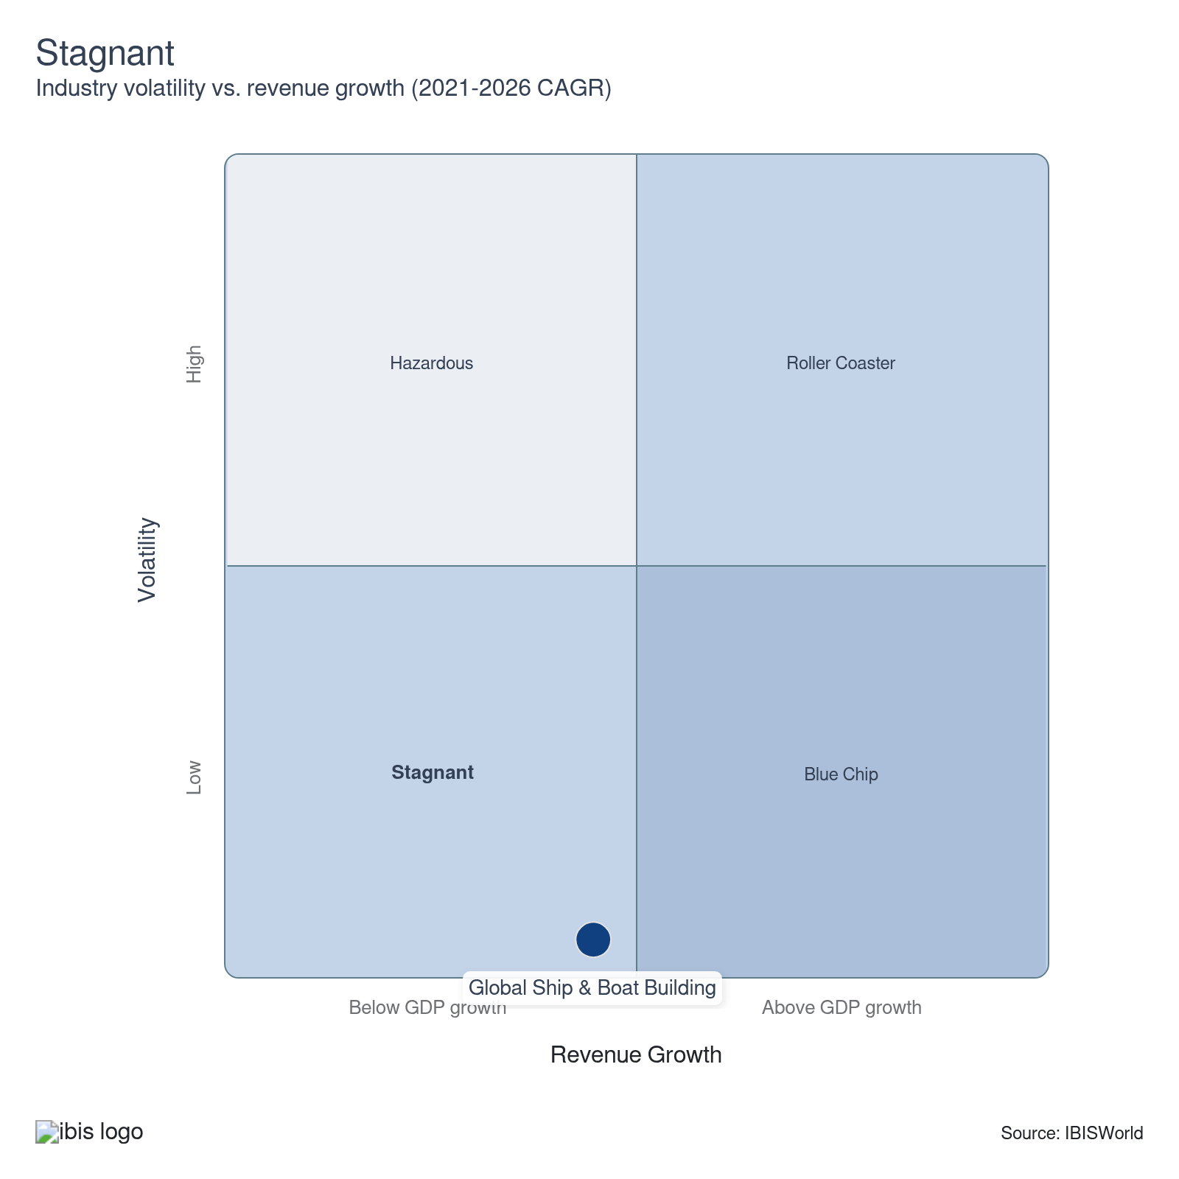

How do successful businesses overcome volatility?
Financial structure of the company
Due to the long lead times in the design, construction and delivery of ships, operators need to have a strong financial structure.
Access to export markets
Larger shipbuilders have developed market penetration strategies. These strategies have been intended to grow and develop their product and market opportunities in overseas markets.
Hire an experienced workforce
Shipbuilding requires a variety of people with different specializations because of its technical requirements and different components and procedures.
Outlook | ↑ 2026-31 Revenue CAGR +1.9%

What's driving the industry outlook?

Defense spending will sustain demand for military vessels in the coming years
- Global naval procurement is set to remain a core source of demand for shipbuilders. Mirae Asset Securities Research estimates that global naval procurement spending will reach $159.0 billion in 2026, with most naval vessels in active service built before 2000 and over 1,000 ships estimated to require replacement in the coming decade. This aging fleet creates a structural pipeline of orders that is unlikely to be affected by short-term economic cycles, giving military-focused shipbuilders a degree of insulation from commercial market volatility.
- The MASGA (Make American Shipbuilding Great Again) initiative between South Korea and the US is expected to generate new contract opportunities as both countries seek to expand naval shipbuilding capacity. Korean builders are expected to begin signing substantial naval vessel export contracts in 2026 and 2027, according to Mirae Asset Securities Research, with HD Hyundai Heavy Industries targeting $7.2 billion in annual defense-related revenue by 2035, according to HD Korea Shipbuilding & Offshore Engineering. The initiative may also authorize the construction of US-flagged vessels in Korean yards, representing a significant shift in procurement policy.
- Non-NATO defense spending, particularly from countries such as India and Saudi Arabia, is forecast to continue rising through the outlook period, while European NATO members are also increasing military budgets in response to regional security concerns. Navies are increasingly prioritizing the technological sophistication of their fleets over sheer numbers, which will push demand toward advanced and specialized support vessels and lift average contract values.
- The military vessels segment is positioned to grow faster than the broader industry. As contract values rise for more complex ships, profit margin on military work is expected to improve, supporting a gradual recovery in industry-wide profitability through 2031. However, escalating geopolitical conflict or major defense procurement shifts could accelerate or disrupt the trajectory of these forecasts.

Trade policy uncertainty will continue to shape ordering decisions
- The evolving US tariff landscape will remain a significant factor for shipbuilders in the coming years. Section 232 tariffs on steel and aluminum stand at 50.0%, and the April 2026 expansion to cover the full customs value of derivative products adds further cost pressure for builders sourcing materials globally. If these tariff levels persist, shipbuilders – particularly those in the US – will need to continue adjusting their supply chains and pricing strategies to manage elevated input costs.
- The suspended Section 301 port fees targeting Chinese-built vessels represent another source of uncertainty. The one-year suspension runs through November 2026, and the outcome of negotiations between the United States and China will influence where shipowners choose to place future orders. If the fees are reimposed, they could accelerate a shift in ordering away from Chinese yards toward South Korean, Japanese and emerging Southeast Asian builders. If they are permanently dropped, Chinese yards will likely regain some of the market share that slipped in 2025.
- More broadly, the total value of world trade is forecast to grow modestly in the coming years, supporting baseline demand for commercial vessels. However, the pace of trade growth is contingent on the broader tariff environment and geopolitical stability. Shipbuilders with diversified order books spanning military, commercial and industrial segments will be best positioned to navigate periods of trade uncertainty.

Uncertainty in the Strait of Hormuz may reshape trade patterns and fleet planning
- The resolution of the conflict between the US and Iran will be a key variable for global shipbuilding in the coming years. If disruption to the Strait of Hormuz continues or recurs, shipping companies may need to permanently reroute vessels through longer alternative passages, which would increase demand for additional tonnage to maintain delivery schedules.
- Energy market volatility stemming from the conflict could also influence the types of vessels ordered. If oil and LNG trade flows shift away from the Persian Gulf toward alternative supply sources, demand patterns for tankers and LNG carriers may change accordingly. Shipbuilders that can offer flexible vessel designs capable of serving multiple trade routes will be better positioned to capture orders in an uncertain environment.
- For shipbuilders, sustained elevated oil prices will raise production costs through higher energy and raw material expenses, potentially compressing profit. However, the same price environment tends to stimulate investment in offshore oil and gas exploration, which could support demand for specialized industrial vessels, including offshore support vessels and drilling ships. The industrial segment is positioned to capture some of this demand.
- Regardless of the outcome of the conflict with Iran, the episode highlights the vulnerability of global maritime trade to chokepoint disruption. This may accelerate investment in naval escort capabilities and maritime security infrastructure, generating additional demand for the industry in the coming years.

Skilled labor shortages will constrain capacity and push up costs
- The shipbuilding industry faces a growing labor challenge that is expected to intensify through 2031. The OECD estimates that 40.0% of the workforce in shipbuilding and maritime equipment industries will retire in the coming decade, while the green and digital transitions are introducing new skill demands that the existing workforce is not equipped to meet. South Korea and Japan, the second- and third-largest shipbuilding nations, face particular pressure from declining populations that are raising labor costs and limiting capacity expansion.
- This labor constraint carries strategic implications for how the industry develops. Shipbuilders that invest in automation, robotics and digital manufacturing tools will be better positioned to maintain output despite a shrinking labor pool. However, the upfront capital required for these investments favors larger builders over smaller operators, reinforcing the consolidation trend and raising barriers to entry for potential new competitors.
- The labor shortage also affects the types of vessels that shipbuilders can efficiently produce. Complex naval vessels and specialized ships require highly skilled engineers and tradespeople whose expertise cannot be easily replaced by automation. As demand shifts toward these higher-specification vessels, competition for qualified workers will intensify, putting upward pressure on wages.
Life Cycle | Mature

Why is the industry mature?

Contribution to GDP
Shipbuilding's contribution to the global economy is growing more slowly than GDP overall, consistent with a mature industry. The sector remains essential to international commerce — seaborne trade moves the vast majority of global merchandise — but its output growth has settled into a narrow band that tracks broader economic expansion rather than outpacing it.

Market Saturation
The market is moderately saturated. The number of establishments and enterprises has edged up in recent years after a period of contraction, but the total remains well below the peak levels from a decade ago when overcapacity forced widespread yard closures. New organic growth opportunities are limited primarily to alternative-fuel vessel categories and emerging shipbuilding nations.

Innovation
Shipbuilders are investing in alternative propulsion systems, digital design tools and energy-efficient hull forms to meet tightening emissions standards. Innovation is focused on meeting regulatory requirements and improving fuel efficiency rather than creating entirely new product categories, which is typical of a mature industry adapting to external pressures rather than one in a rapid growth phase.

Consolidation
Mergers and acquisitions continue to reshape the competitive landscape. South Korea's HD Hyundai Heavy Industries completed its merger with HD Hyundai Mipo Dockyard in December 2025, while China State Shipbuilding Corporation consolidated its position as the world's largest builder following its own earlier merger. These deals reflect a mature industry where scale is increasingly necessary to compete for high-value contracts and absorb the R&D costs of next-generation vessel design.

Technology & Systems
Shipyards are adopting automation, robotic welding and digital monitoring systems to improve production efficiency and reduce labor costs. These technologies are making their way into yards at varying rates — large East Asian builders lead in adoption, while smaller yards in emerging markets are still upgrading. The uneven pace of technology adoption reinforces the competitive gap between top-tier builders and the rest of the industry.

4. Products and Markets
https://my.ibisworld.com/gl/en/industry/C2541-GL/products-and-markets

Key Takeaways
- In June 2025, the US enforced a 50.0% tariff on steel and aluminum imports. This move potentially boosts non-US shipbuilders by reducing material expenses for components like hulls and frames, as suppliers will have more inventory available because of potential decreased US interest in these materials.
- Geopolitical tensions and defense budgets influence demand for military vessels. Nations bolster naval fleets to enhance national security and global power projection. Regular upgrades and replacements are vital for maintaining fleet readiness and efficiency.
- Economic growth and international trade boost demand for commercial vessels. Growing trade requires more container ships, bulk carriers and tankers, while older vessels need to be replaced.

Products and Services
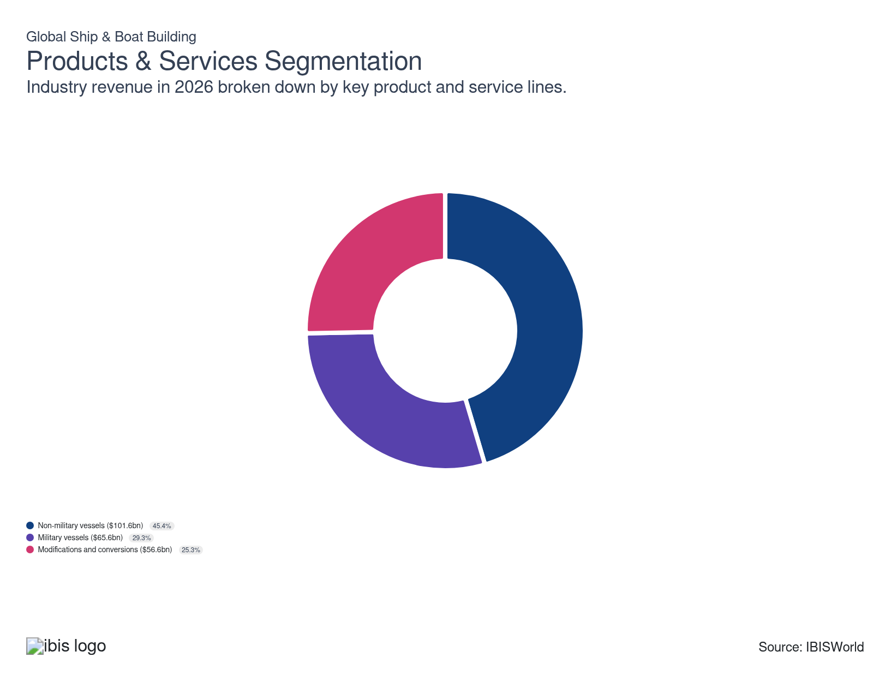

How are the industry’s products and services performing?

Economic trends continue to expand the need for commercial and industrial vessels
- Swelling international trade continues to bolster the need for commercial vessels like container ships, bulk carriers and tankers to transport goods. Older commercial vessels are often replaced with newer, more efficient and environmentally compliant ships, giving builders in this segment a constant backlog.
- The offshore oil and gas industry drives demand for specialized vessels such as offshore support vessels (OSVs), drilling ships and LNG carriers. Additionally, stricter environmental regulations push for the development of eco-friendly vessels, including LNG-powered ships and hybrid propulsion systems.

Changes in demand and replacement cycles drive demand for military vessels
- Countries invest in naval capabilities to protect national interests, secure maritime borders and project power globally. Increased geopolitical tensions and regional conflicts drive nations to bolster their naval fleets for deterrence and defense.
- Defense budgets and government policies significantly impact the procurement of military vessels, with countries allocating substantial funds to naval defense. Along with changes in demand, regular upgrades and replacement of aging fleets are essential for maintaining operational readiness and efficiency.

Advances in technology drive demand for upgrades and conversions
- Vessels must comply with evolving international regulations, such as emission standards, which drive demand for retrofits and upgrades. Additionally, shipowners seek to enhance the operational efficiency and lifespan of existing vessels through modifications.
- Advances in technology drive demand for upgrades to navigation systems, propulsion systems and safety equipment. Modifying or converting existing vessels can be more cost-effective than building new ships, especially in a fluctuating economic environment.

What are innovations in industry products and services?

Alternative-fuel propulsion is the most significant design shift in decades
- Half of all orders by tonnage in 2024 involved alternative fuel, according to Clarkson Research, with LNG dual-fuel systems leading the order book. Methanol-capable vessels are also gaining ground among container operators aligning with the EU's FuelEU Maritime regulation.
- These changes ripple through the entire vessel design chain, from fuel storage layouts to engine room safety protocols. Shipyards that can integrate dual-fuel capability into standard hull designs hold a competitive advantage as buyers demand flexibility across fuel types and regulatory regimes.

Digital tools are improving shipyard efficiency and vessel performance
- Shipyards are deploying digital twins, AI-driven design optimization and robotic welding to cut build times and reduce rework. Digital twins simulate vessel performance before physical construction begins, catching design issues early and lowering costs.
- According to Clarkson Research, 44.0% of fleet tonnage is now equipped with Energy Saving Technologies, reflecting broader adoption of efficiency-focused innovations. These features are becoming standard on larger commercial vessels where fuel savings over a 20-year operational life justify the upfront investment.

What products or services do successful businesses offer?
Invest in research and development
Constant innovation through research and development ensures shipbuilders stay competitive with advanced technologies and efficient production methods, which are crucial for meeting evolving market demands and maintaining high-quality standards.
Produce high value-added goods
Focusing on high-value products enhances profitability and market positioning. By integrating superior design, quality and branding, shipbuilders can justify premium pricing, attracting discerning customers seeking reliability and innovation.

Major Markets
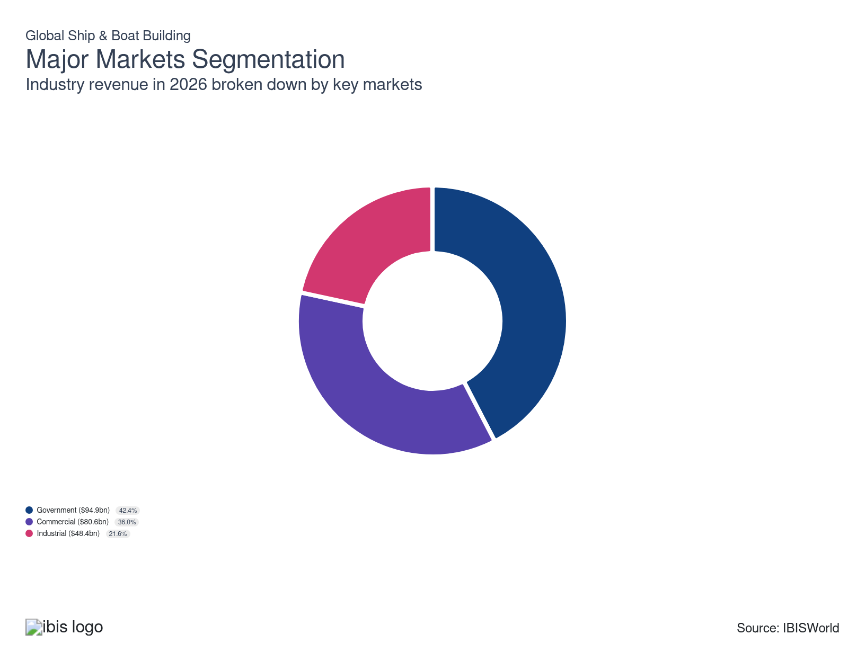

What’s influencing demand from the industry’s markets?

Government procurement remains the largest market driven by defense and public infrastructure needs
- Government contracts represent the largest source of revenue for the global shipbuilding industry. Defense agencies commission warships, submarines, patrol vessels and naval support ships through procurement programs that typically span multiple years. These contracts carry high per-unit values and provide builders with predictable workloads, making government buyers the most reliable source of demand. Nations maintain naval fleets both for active operations and as a deterrent, which sustains a baseline level of ordering even in periods of relative stability.
- Governments also commission non-defense vessels for public infrastructure purposes, including icebreakers, research ships and coast guard cutters. These vessels support scientific exploration, resource mapping and maritime law enforcement in remote or extreme environments. Public investment in maritime infrastructure tends to follow long planning cycles, adding a layer of stability to government demand that commercial markets do not provide.

Shipping companies drive commercial demand as fleet capacity must keep pace with trade volumes
- Commercial buyers — primarily shipping lines, tanker operators and offshore logistics firms — purchase vessels to move freight across international trade routes. Fleet operators must continuously balance their capacity against trade demand, ordering new vessels when existing ships age out, when routes shift or when cargo volumes outgrow current fleet size.
- Environmental compliance is becoming a factor in commercial purchasing decisions. Shipowners that operate older, less efficient vessels face rising regulatory costs under the IMO's tightening carbon intensity framework. For many commercial operators, ordering a new vessel designed for compliance is becoming more cost-effective over a 20-year operational life than continuing to operate and retrofit an aging ship. This regulatory pressure adds a compliance-driven layer of demand on top of the traditional trade-volume-driven ordering cycle.

Oil and gas remains crucial to industrial shipbuilders
- The industrial segment encompasses vessels built for resource extraction and processing rather than freight transport. Offshore drilling platforms, floating production storage and offloading units (FPSOs) and support vessels for the oil and gas industry account for the largest share of this market. Demand in this category tracks global energy investment — when oil prices rise and exploration budgets expand, orders for specialized offshore vessels follow.
- Industrial fishing fleets represent a smaller but steady component of the segment. Large-scale commercial fishing operations require purpose-built trawlers, longliners and processing vessels designed for extended voyages. Fleet replacement in this category is driven by aging vessels and evolving fisheries regulations that mandate improved catch monitoring, fuel efficiency and crew safety standards.

International Trade
Total Imports  $47.9bn  ’21-’26 ↓ 2.2 %  ’26-’31 ↑ 2.1 % | Total Exports  $47.9bn  ’21-’26 ↓ 2.2 %  ’26-’31 ↑ 2.1 % | Trade Balance  Balanced  : $0

International Trade Imports
International Trade Imports
International Trade Exports
International Trade Exports

Imports
Moderate | Decreasing

What are the industry’s import trends?

An aging global fleet is sustaining import demand across many countries
- Weighted by gross tonnage, the global maritime fleet averaged 12.6 years old in 2024, according to UNCTAD's Review of Maritime Transport 2025, with more than half of the fleet over 15 years old by vessel count. Tightening IMO decarbonization regulations are pushing shipowners to replace or retrofit older vessels. Countries that lack domestic shipbuilding infrastructure — or that cannot produce specialized vessel types domestically — must import to keep their fleets competitive and compliant. India and Saudi Arabia are among the most consistent importers, driven by fleet modernization programs and expanding maritime trade volumes that outpace their domestic yards' capacity.
- Delivery backlogs at major shipyards now extend beyond 3 years for many vessel categories, which compounds reliance on imports for countries with urgent fleet needs. Defense procurement adds another layer: nations seeking advanced naval vessels often import from established military shipbuilders in South Korea, Europe or the United States because domestic alternatives either do not exist or cannot meet the required technical specifications within acceptable timelines.

Emerging shipbuilding nations are diversifying global import sourcing
- Vietnam, Turkey and Poland have grown as alternative shipbuilding sources for countries seeking to diversify away from the traditional East Asian and European yards. These emerging builders offer competitive pricing and shorter lead times for standard commercial vessel types, giving importers more flexibility in their supply chains. Vietnam has been expanding rapidly, building tankers, bulkers and container vessels for both domestic use and export, according to UNCTAD.
- The broader trend toward supply chain diversification reflects lessons learned from recent trade disruptions. Countries that previously relied on a single source for vessel procurement are increasingly splitting orders across multiple builders and regions to manage risk. However, for the most technically complex vessels — LNG carriers, advanced military combatants and large cruise ships — buyers continue to depend on a small number of established yards in South Korea, China, Italy and France, where the specialized engineering capability and production infrastructure exist.

Exports
High | Decreasing

What are the industry’s export trends?

China and South Korea account for the majority of global shipbuilding exports
- China, South Korea and Japan collectively account for an estimated 95.0% of global shipbuilding output, according to UNCTAD. China has emerged as the single largest producer by a wide margin, delivering more than half of the world's vessel capacity for the first time in 2023 and extending that lead since. South Korea has retained a strong export position by concentrating on high-value vessel types, while Japan maintains a significant base in bulk carriers and energy-efficient commercial ships.
- The concentration of production in East Asia means that most shipbuilding trade flows outward from the region. Buyers across Europe, the Middle East and South Asia rely on East Asian yards to fill orders that their domestic shipbuilding industries cannot accommodate, whether because of limited capacity, higher labor costs or a lack of technical capability for specialized vessel types.

Trade disruptions and policy shifts are redirecting shipbuilding-related commerce
- Geopolitical tensions and trade policy changes have altered global shipping patterns, with routes increasingly redirected away from traditional chokepoints, according to UNCTAD's Review of Maritime Transport 2025. Rerouting around the Cape of Good Hope has increased vessel ton-mile demand and strained existing fleet capacity, which may support new orders over time. At the same time, the US is pursuing domestic-focused industrial policies to boost national shipbuilding capacity, including proposed port fees targeting Chinese-built vessels, which could shift ordering patterns if implemented.
- US tariffs on steel and aluminum imports have added cost pressure for builders that source materials internationally, while retaliatory measures from trading partners have complicated supply chains for shipbuilding components. The conflict between the US and Iran has introduced additional uncertainty for vessels transiting the Persian Gulf, raising insurance costs and delivery timelines for ships bound for Middle Eastern and South Asian buyers.

5. Geographic Breakdown
https://my.ibisworld.com/gl/en/industry/C2541-GL/geographic-breakdown

Key Takeaways
- Most global shipbuilding occurs in East Asia. China, Japan and South Korea dominate the industry, making the region a global hub. These countries cater to both domestic and international markets with robust shipbuilding capabilities.
- The US focuses primarily on military shipbuilding. Established during World War II, it emphasizes the construction of costly military vessels. This focus boosts the US's share in dollar terms despite lower global volume.

Business Locations

Where are industry businesses located?

China dominates global shipbuilding with more than half of all output
- China is the largest shipbuilding nation by a wide margin, accounting for more than half of global output and exceeding the combined output of South Korea and Japan. Chinese yards are concentrated along the country's eastern seaboard, with major clusters in Shanghai, Jiangsu and Guangdong provinces. Government investment in shipyard infrastructure has continued to expand capacity, with Clarkson Research tracking the expansion of existing yards and reactivation of dormant facilities across the country.
- China's yards are now fully booked for three to four years, with no new production slots available before the end of 2028, according to Marine Insight. This backlog reflects both the scale of global demand and the concentration of production capacity in China. The country leads in bulk carriers, container ships and tankers and has expanded into high-value categories like LNG carriers, capturing 78.5% of alternative fuel vessel orders in 2024, according to Marine Insight.
- China's output grew 18.0% in 2024 alone, according to Clarkson Research, and the country is the only major producer actively expanding capacity through the enlargement of existing yards and the reactivation of dormant facilities. This expansion is locking in China's dominance for years to come, as new capacity takes time to come online and order backlogs already extend well into the next decade.

South Korea and Japan anchor the rest of East Asia's shipbuilding capacity
- South Korea is the second-largest shipbuilder globally, delivering an estimated 20.1 million GT (Gross Tonnage) in 2024, according to UNCTAD. South Korean yards are concentrated in the southern coastal cities of Ulsan, Geoje and Mokpo, where HD Hyundai Heavy Industries, Hanwha Ocean and Samsung Heavy Industries operate some of the world's largest shipyard complexes. South Korea has maintained its position by specializing in high-value vessel types — the country holds the majority of the global LNG carrier order book and has focused heavily on digitalization and automation in its production processes.
- South Korea's concentration in technologically advanced vessels has allowed it to compete on value rather than volume against China's cost advantage. However, China's growing share of alternative fuel orders is beginning to challenge this differentiation, putting pressure on South Korean yards to maintain their edge through continued investment in digitalization and next-generation propulsion systems.
- Japan remains the third-largest builder, delivering an estimated 9.0 million GT in 2024, though its market share has gradually declined as China has expanded. Japanese yards are distributed across several coastal prefectures, with major operations in Nagasaki, Kure and Ehime. Japan has set a goal to double its shipbuilding capacity and increase its global market share in new orders to 20.0% by 2030, according to Marine Insight, with a focus on energy-efficient vessels and potential consolidation among builders such as Imabari Shipbuilding and Japan Marine United.

European builders focus on high-value vessels while the US centers on defense
- European shipbuilders account for an estimated 2.2% of global output by gross tonnage according to UNCTAD, but concentrate on vessel categories that command higher prices per unit. This includes cruise ships, military vessels and specialized offshore or research vessels. Europe's niche focus means its share of global shipbuilding revenue is meaningfully larger than its share of tonnage.
- Italy's Fincantieri and Germany's Meyer Werft dominate the global cruise ship market, while France's Naval Group and Italy's Fincantieri also lead European naval shipbuilding through programs spanning submarines, frigates and aircraft carriers. Norwegian yards specialize in offshore support vessels and advanced fishing vessels, leveraging decades of North Sea operational expertise. This concentration of specialty capability means European builders secure a disproportionate share of premium contract value despite their modest share of global tonnage.
- The United States produced less than 1.0% of global gross tonnage, according to UNCTAD, representing a negligible share of global volume. However, the US holds a larger share by dollar value because of its focus on high-cost military vessels funded by the Department of Defense. The Jones Act, which requires vessels transporting goods between US ports to be domestically built, supports a small but protected domestic shipbuilding base.
- The gap between commercial and military shipbuilding output distinguishes Western builders from their East Asian counterparts. While East Asian yards compete on scale and speed for commercial contracts, European and US builders derive most of their value from defense procurement and specialty construction, where contract values per vessel are significantly higher but production volumes are far smaller.


How do businesses use location to their advantage?
Access to export markets
Larger shipbuilders have developed market penetration strategies. These strategies have been intended to grow and develop their product and market opportunities in overseas markets.
Operate in a location that is close to key markets
Being near key markets minimizes the cost and time associated with delivering finished ships and boats to customers. This strategic positioning enhances customer satisfaction through faster delivery times and reduces shipping costs, making the company more competitive.
Operate in a location that is close to key suppliers
Proximity to key suppliers reduces transportation time and costs for materials essential for ship and boat building. This leads to efficient production processes and quicker turnaround times, which is a significant competitive advantage in the global market.

6. Competitive Forces
https://my.ibisworld.com/gl/en/industry/C2541-GL/competitive-forces

Key Takeaways
- High capital requirements and long lead times create significant barriers to entry. Building and maintaining shipyards, acquiring specialized equipment and developing the technical workforce needed for complex vessel construction demand substantial upfront investment that deters new entrants.
- Established relationships and reputations pose significant barriers to entry. Long-standing shipbuilders benefit from established client relationships and industry reputations for reliability and quality.

Concentration
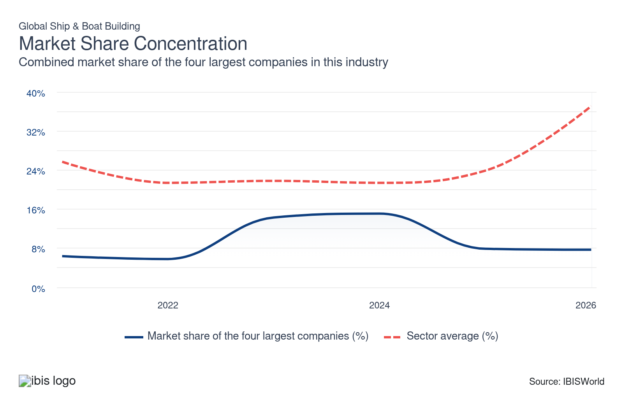

What impacts the industry’s market share concentration?

A highly fragmented boatbuilding segment keeps overall concentration low
- Boatbuilding is a much smaller segment than shipbuilding, but its highly fragmented structure helps hold down industrywide market share concentration. Small boatbuilders typically serve a single region and lack the scale or infrastructure to compete for larger contracts.
- The sheer number of these smaller operators dilutes the market share of the industry's largest players, even though shipbuilding generates the vast majority of revenue. Within the shipbuilding segment itself, concentration is higher but still moderate by heavy manufacturing standards.

Government intervention sustains a broader competitive field than the market would otherwise support
- Government subsidies, preferential lending and protectionist policies in multiple countries keep domestic shipbuilders in operation that might not survive on commercial merit alone. China and South Korea heavily subsidize their yards, while the Jones Act in the United States requires vessels carrying goods between domestic ports to be built domestically. These policies fragment the market by propping up national champions rather than allowing consolidation to follow purely commercial logic.
- The result is an industry where government priorities — defense readiness, employment and industrial strategy — play as large a role in shaping the competitive landscape as market forces. This dynamic limits how concentrated the industry can become, even as the largest builders grow through mergers.

Recent mergers are consolidating capacity among the top builders
- Despite the structural forces that limit concentration, the largest shipbuilders are consolidating. HD Hyundai Heavy Industries completed its merger with HD Hyundai Mipo Dockyard in December 2025, creating a unified builder with expanded capacity across large and mid-sized vessel construction. China State Shipbuilding Corporation remains the world's largest builder following its own consolidation. These mergers concentrate high-value contract capacity among fewer top-tier yards, even as hundreds of smaller builders continue to operate at the lower end of the market.
- The growing technical complexity and capital requirements of modern vessels — particularly LNG carriers, advanced military combatants and dual-fuel commercial ships — favor larger builders that can invest in R&D and specialized production infrastructure. Smaller yards that cannot keep pace with these requirements face increasing pressure to specialize in niche markets or exit the market.

How do successful businesses handle concentration?
Undertaking technical research and development
Due to changes in customer demand, innovations in the design, development and manufacturing of ships and boats are important competitive attributes.
Financial structure of the company
Due to the long lead times in the design, construction and delivery of ships (and in some cases, boats), operators need to have a strong financial structure.
Hire an experienced workforce
Shipbuilding requires highly specialized skills in design, engineering, welding and assembly. Access to a workforce with these skills can enhance productivity and quality, making a company more more competitive and equipped for new projects.

Barriers to Entry
High | Steady

What challenges do potential industry entrants face?

Legal
- Regulations are tight for shipbuilders. Many governments provide lots of assistance to shipbuilders, which may need to follow certain rules to receive, while working standards are also tight to ensure safety, both during construction and of a completed vessel.

Start-up Costs
- Start-up costs for potential shipbuilders are intense. Drydocks require a lot of space and need to be located on the coast or near a navigable waterway, which limits the areas in which they can set up operations.

Differentiation
- Shipbuilders are consistently adding new technology to their vessels to differentiate themselves from their competitors. They also try to build larger ships that will still fit in existing ports to boost capacity.

Labor Expenses
- Shipbuilders need highly skilled labor to build ships successfully. These include welders and engineers to design the vessels. Despite high levels of capital needed for operations, labor is still a huge expense.

Capital Expenses
- Constructing and maintaining large shipyards capable of building and assembling ships require significant expenditure. These shipyards need extensive berths, dry docks and specialized equipment for handling large structures, resulting in high capital expenditures.

How can potential entrants overcome barriers to entry?
Develop strong technical product knowledge
Mastering the technological intricacies of ship and boat building is crucial. It ensures the production of high-quality, innovative vessels and helps avoid costly mistakes. This expertise establishes barriers against new entrants who lack in-depth technical knowledge.
Maintain and increase contracted advertising revenues or access to government funding
Landing government contracts can provide a stable and substantial revenue stream. Governments often commission large-scale projects like naval ships and coast guard vessels, ensuring long-term business. This steady demand helps buffer against market fluctuations and establishes barriers for new entrants.

Substitutes
Low | Steady

What are substitutes for industry services?

Global Commercial Aircraft Manufacturing
- Aircraft provide significantly faster travel times compared to ships. While an ocean voyage can take several days or even weeks, a flight can cover the same distance in hours. This major advantage is particularly attractive for business travelers and tourists who prioritize speed and flexibility in their schedules.
- Airports are strategically located near major cities and economic hubs, ensuring efficient linkages to global destinations. The vast network of flights and frequent schedules offers passengers more immediate and convenient options compared to maritime routes, which are relatively fixed and less frequent.
- Air freight is paramount in industries where time is crucial, such as pharmaceuticals, electronics, and perishable goods. The ability to ship goods across continents in a matter of hours as opposed to weeks provides businesses with a significant logistical advantage over maritime shipping.

Global Military Aircraft & Aerospace Manufacturing
- The evolving nature of modern warfare, which often includes asymmetrical and hybrid threats, makes versatile air power crucial. These threats require rapid engagement and precision, tasks at which aircraft excel. Naval ships, while indispensable for certain missions, may not always be the optimal choice for quick, low-footprint operations in varied and unpredictable conflict environments.
- The rise of drones and other unmanned systems adds a new dimension to military aviation, enabling persistent surveillance, targeted strikes, and electronic warfare with reduced risk to personnel. These capabilities complement and, in some scenarios, substitute the need for extended naval deployments, impacting how military resources are allocated.

Global Heavy-Duty Truck Manufacturing
- Heavy-duty trucks are integral to intermodal transportation systems, where they complement maritime, rail, and air transport modes. Trucks handle the critical first and last legs of cargo journeys, bridging the gap between different transport options and providing a comprehensive logistics solution. This integration ensures the efficient movement of goods across various transport networks.
- Trucks offer greater operational flexibility in adjusting routes, schedules, and loads based on real-time demand and external factors. This adaptability can lead to optimized routes, reduced fuel consumption, and lower overall transportation costs, offering a competitive edge over fixed and longer-duration maritime routes.

How do successful businesses compete with substitutes?
Invest in new technology to enhance operational efficiency and quality
Investing in new technology ensures that the company remains competitive by improving production processes, reducing costs and enhancing the quality of ships and boats. This helps to combat substitute competition by offering superior products.
Produce a differentiated product
Creating unique and innovative products sets the company apart from competitors. Differentiation attracts customers seeking specialized features or designs, effectively reducing the likelihood of them choosing substitutes from competitors.

Buyer & Supplier Power
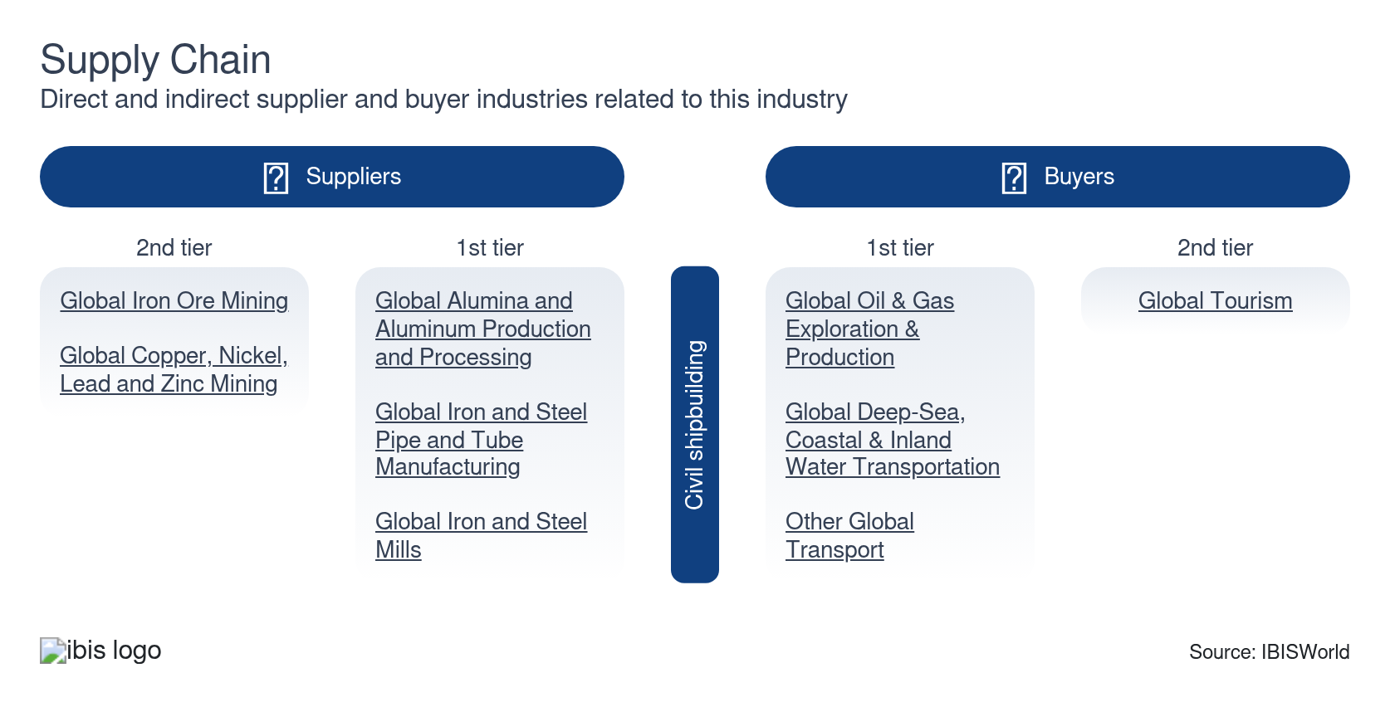

What power do buyers and suppliers have over the industry?

Buyers: Limited options
Low | Steady
- Maritime shipping capacity is fixed in the short term, which means that shipping companies that need to boost their capacity and expand their fleet have few options to do so, as lead times to build new ships can be years.
- Particularly for military uses, many governments will also have strict requirements for which companies can build their ships, which also increases the power of shipbuilders.

Suppliers: Steel is essential
Moderate | Steady
- Steel is a crucial input into ships. The hulls of most commercial and military vessels are made from the alloy and also is the base material for many crucial parts throughout the ship.
- The world price of steel is heavily volatile and is reliant on many different market factors. There isn't a reliable substitute for steel when prices are high, so shipbuilders are forced to pay the heightened cost.
- Despite this, supplier power is limited as shipbuilders are able to successfully pass on any price increases to downstream shipping companies that also need cargo vessels.

How do successful businesses manage buyer & supplier power?
Access to export markets
Larger shipbuilders have developed market penetration strategies. These strategies have been intended to grow and develop their product and market opportunities in overseas markets.
Leverage the degree of vertical integration within the company
By integrating various stages of the production process, ship and boat builders can directly control their supply chain, mitigating the bargaining power of suppliers while also potentially reducing costs and ensuring timely delivery, enhancing overall competitiveness.
Establish long-term working relationships with raw material suppliers
Building strong, enduring partnerships with suppliers ensures stable supply, potentially at better prices. This reduces the risk of supply shortages or price volatility, which can be crucial in maintaining steady production and competitive pricing.

7. Companies
https://my.ibisworld.com/gl/en/industry/C2541-GL/companies

Key Takeaways
- HD Hyundai Heavy Industries completed its merger with HD Hyundai Mipo Dockyard in December 2025. The combined entity now operates as a unified builder with expanded capacity across large-scale and mid-sized vessel construction, targeting $7.2 billion in annual defense-related revenue by 2035.
- The largest companies are heavily reliant on big orders. Most major players had significant ship orders recently, which have boosted revenue.

Market Share
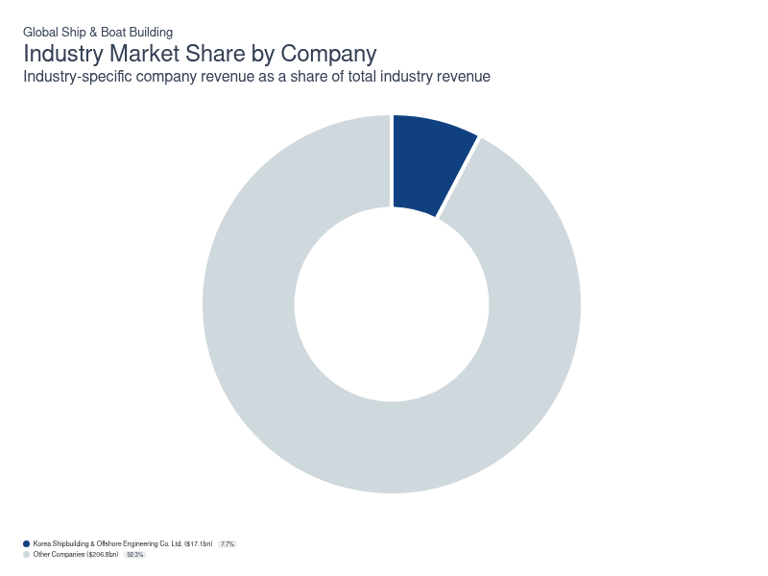
Chart displays current year only in the PDF version of this report. You can view and download chart for all other years associated with this industry on my.ibisworld.com.

Companies
Company | Market Share (%)  2026 | Revenue ($m)  2026 | Profit ($m)  2026 | Profit Margin (%)  2026
Korea Shipbuilding & Offshore Engineering Co. Ltd. | 7.7 | 17,147.3 | 595.1 | 3.5

Korea Shipbuilding & Offshore Engineering Co. Ltd.
Korea Shipbuilding & Offshore Engineering Co. Ltd.
Company Details
Company Details
Industry Specific Revenue (2026) | $17.1bn
Industry Profit (2026) | $595.1m
Market Share (2026) | 7.7%

Description
Description
As a result of Hyundai Heavy Industries Co. Ltd. (HHI) being split in 2019, Korea Shipbuilding & Offshore Engineering Co. Ltd. (KOSE) was formed. KOSE is still a subholding company of HHI, with its primary focus being on shipbuilding and offshore businesses. The South Korea-based company manufactures bulk carriers, container ships, tanker ships, multipurpose cargo ships, liquefied petroleum gas carrier ships and chemical cargo ships, among others. HHI manufactures these products through its subsidiaries Hyundai Heavy Industries, Hyundai Mipo Dockyard and Hyundai Samho Heavy Industries.

Company’s Industry Revenue, Market Share, and Profit Margin Over Time
Company’s Industry Revenue, Market Share, and Profit Margin Over Time
Year | Industry Revenue ($ million) | Market Share (%) | Profit Margin (%)
2020 | 10574 | 6.0 | 1.8
2021 | 11722 | 6.4 | -5.4
2022 | 11268 | 5.8 | 1.1
2023 | 13541 | 6.7 | 1.7
2024 | 16179 | 7.7 | 6.8
2025 | 17147 | 7.9 | 3.5
2026 | 17147 | 7.7 | 3.5

What's impacting Korea Shipbuilding & Offshore Engineering Co. Ltd.'s performance?

Company reports first-half 2023 revenue
- Korea Shipbuilding and Offshore Engineering Co. Ltd. announced its first-half results in July 2023. The company reported a record KRW 5.4 trillion ($4.2 billion) in revenue over the first six months of the year, along with KRW 71.2 billion ($55.8 million) in operating profit, which is measured as earnings before interest and taxes. Company officials reported improved shipbuilding activity, in addition to marine engine supply. The company had operating losses in recent years, but has returned to profit, a trend that is expected to accelerate through the rest of the year, as it expects vessel prices to rise.

Capital Marine Group to buy liquid carbon dioxide carriers
- A shipper based in Greece, Capital Marine Group, purchased in July 2023 two liquid carbon dioxide carriers in the 22,000 cubic meter class. The vessels, which will be among the largest of their type in the world, measure 27.4 meters in width, 159.9 meters in length, and 17.8 meters in height. They will be built at the shipyard in Ulsan's Hyundai Mipo Dockyard and be delivered in late 2025. Capital Marine Group will pay KRW $179.0 ($140.3 million) for the two vessels.

Korea Shipbuilding secures $140.0 million contract
- Korea Shipbuilding and Offshore Engineering Co. Ltd. announced in July 2023 that it had secured a contract worth KRW 176.2 billion ($140.0 million) for two petrochemical carriers. The ships, which are scheduled to be delivered in June 2026, were purchased by an unnamed company based in the Bahamas. It's unclear how large each vessel will be or what their capacity will be. This large contract and long lead time is indicative of how boom or bust shipbuilding can be.

You can view and download company details on my.ibisworld.com.

8. External Environment
https://my.ibisworld.com/gl/en/industry/C2541-GL/external-environment

Key Takeaways
- Economic growth significantly affects the global shipbuilding industry. Rising GDP and increased international trade boost demand for commercial vessels like container ships and tankers.
- Geopolitical tensions and defense budgets impact demand for military vessels. Countries invest in their naval capabilities to protect national interests and secure maritime borders.

External Drivers

What demographic and macroeconomic factors impact the industry?
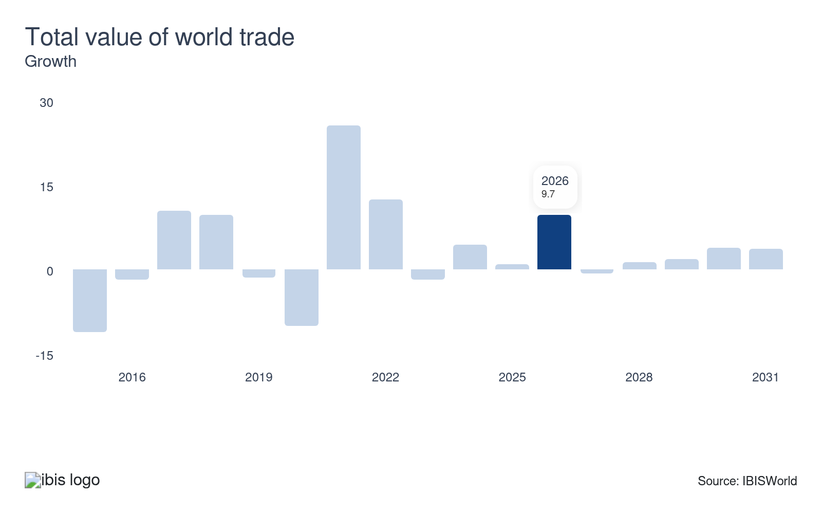
Ships are involved in the majority of world trade. When the total value of world trade rises, demand for shipping increases. If the value of trade increases quickly, demand for ships will likely lag due to the long lead times to build a ship. A sustained increase in the total value of world trade can positively affect demand for new ships.

Boatbuilders are highly attuned to fluctuations in consumer spending. Higher consumer spending is associated with higher demand for various boats, such as cabin cruisers, dinghies, motorboats, rowboats, sailboats and yachts. Additionally, increased consumer spending boosts demand for goods that require transportation, subsequently raising demand for ships and other transport vessels. Therefore, higher consumer spending represents a potential opportunity for the industry.
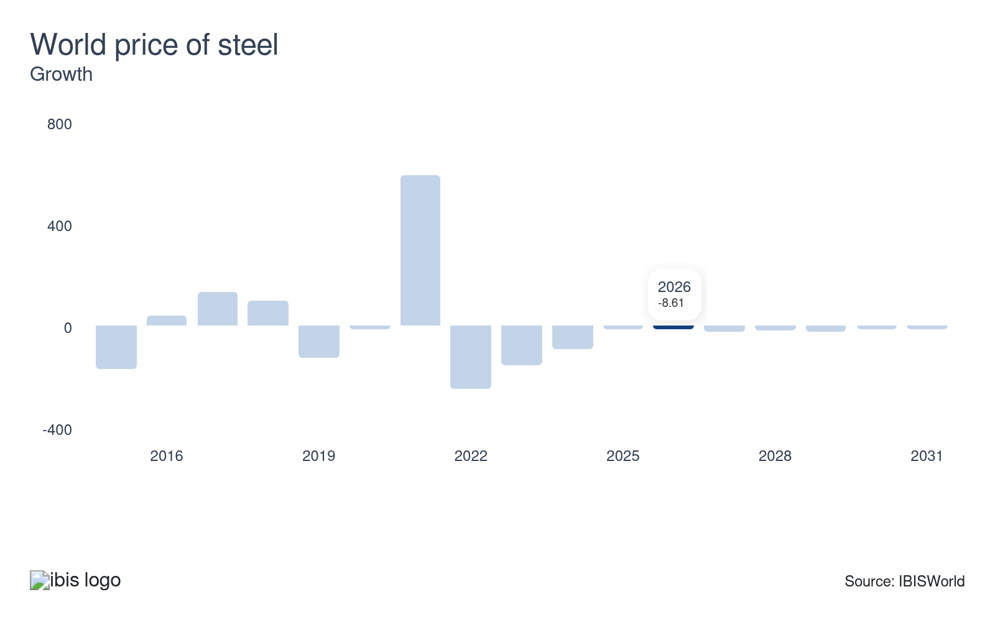
An increase in steel prices raises shipbuilders' production costs, making ships more expensive to produce. Changes in steel prices can lead to adjustments in ship pricing. If steel prices increase, shipbuilders may need to raise prices to maintain profitability. Higher steel prices may impact profit, thus posing a potential threat to the industry.
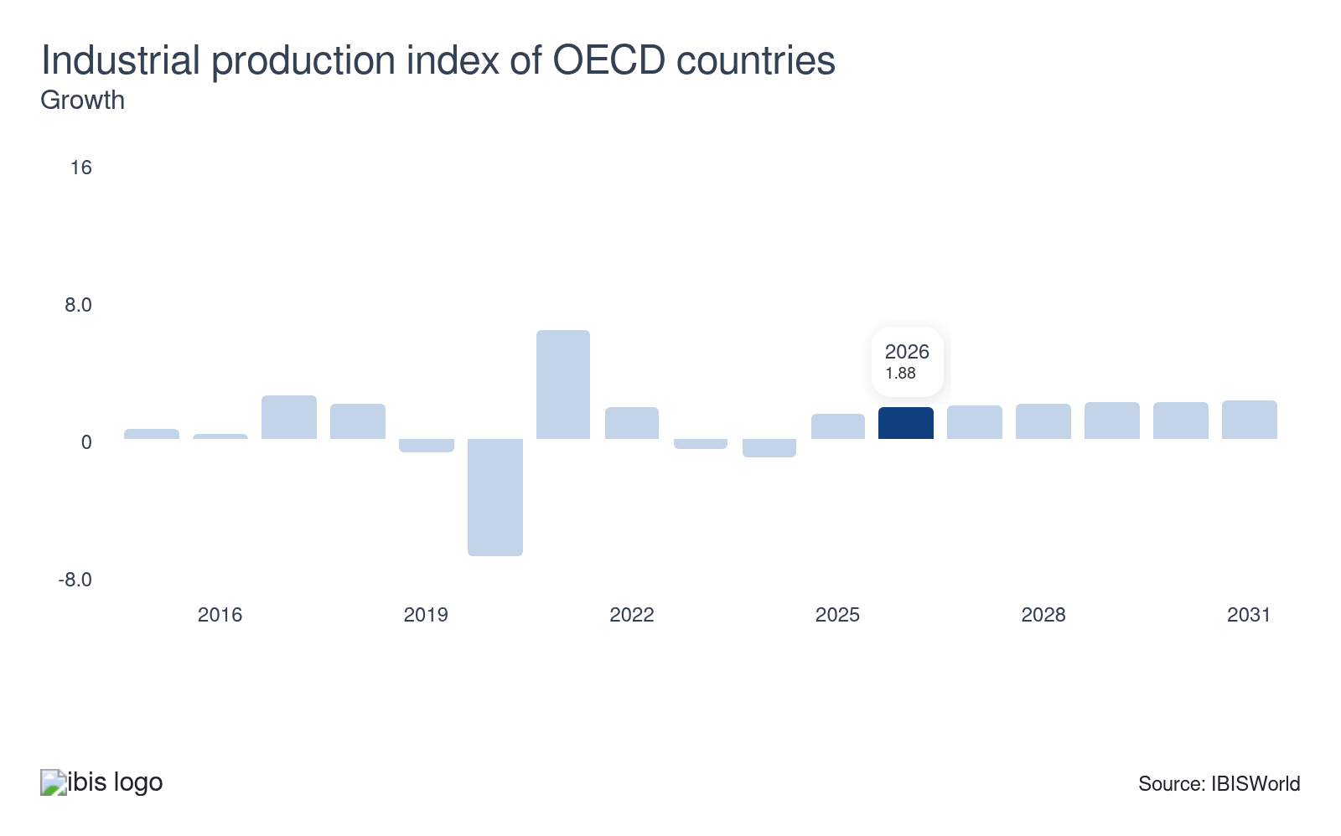
The industrial production index of countries in the Organization for Economic Co-operation and Development (OECD) measures industrial production from 37 countries, including the United States, the United Kingdom, Germany, France, Japan, South Korea and Australia. The index measures these nations' output in the manufacturing, mining, electric, gas and water utilities industries. As the index rises, more goods need to be shipped, boosting demand for ships produced by the industry.

Regulation & Policy

What regulations impact the industry?

International Convention for the Safety of Life at Sea (SOLAS)
SOLAS mandates comprehensive safety measures for ships, including life-saving appliances, fire protection, and navigation systems. For example, shipbuilders must integrate advanced fire suppression systems and ensure structural integrity to avoid hazards. This ensures vessels are safe for crew members and passengers, maintaining high standards across the industry. Compliance can lead to increased costs, but it significantly reduces risks, potentially lowering insurance premiums and enhancing the shipyard's reputation.

Ballast Water Management Convention (BWMC)
The BWMC aims to prevent the transfer of aquatic invasive species by regulating ships' ballast water discharge. This requires shipbuilders to fit vessels with advanced ballast water treatment systems. These systems can increase a vessel's initial cost but are essential for legal compliance. An example is the adoption of UV treatment technology, which prevents ships from introducing harmful species into new environments. The convention has created steady demand for purpose-built treatment system integration in new construction and retrofit projects, with treatment system manufacturers now a standard part of the maritime supply chain.

European Union Ship Recycling Regulation (EUSRR)
EUSRR enforces the safe and environmentally sound recycling of EU-flagged ships. Shipbuilders must prioritize design elements that facilitate easy disassembly and recycling, using materials that pose minimal environmental hazards. An example is adopting modular construction techniques to simplify the decommissioning process. This regulation promotes sustainability and augments the industry's contribution to the circular economy, encouraging builders to consider a vessel’s entire lifecycle during the design phase.

IMO Net-Zero Framework
The IMO approved a binding emissions framework in April 2025 that introduces mandatory greenhouse gas fuel intensity targets for ships over 5,000 gross tonnage, according to the Global Maritime Forum. Beginning January 1, 2028, vessels must meet annual carbon intensity limits measured on a well-to-wake basis, with targets tightening each year through 2035. Ships that exceed their limits must purchase remedial units at $380 per ton of CO2 equivalent, with proceeds funding clean fuel development and transition support for developing nations, according to the IMO. This framework represents the most significant regulatory change for shipbuilders in decades, effectively mandating that new vessels be designed with future fuel flexibility in mind.

FuelEU Maritime Regulation
The European Union's FuelEU Maritime regulation took effect in January 2025 and sets greenhouse gas intensity thresholds for marine fuels used by vessels calling at EU ports. Shipbuilders constructing vessels for European trade routes must account for these requirements at the design stage, particularly around fuel storage and dual-fuel propulsion capability. The regulation complements the IMO framework but applies on a regional basis, creating an additional compliance layer for builders serving European buyers.

International Maritime Organization (IMO) 2020 Sulfur Cap
The IMO 2020 Sulfur Cap limits the sulfur content of marine fuels to 0.50%, a drastic reduction from the previous 3.50%. This forces shipbuilders to design ships capable of running on low-sulfur fuels or to install scrubbers to clean exhaust emissions. The push for compliance has fostered innovation in alternative propulsion systems, such as LNG (liquefied natural gas) engines. For shipbuilders, the regulation has also opened a steady pipeline of retrofit and conversion work, as owners of older vessels install scrubbers or upgrade fuel systems to remain compliant rather than prematurely scrapping ships.

Assistance

What assistance is available to this industry?

Jones Act
The Jones Act requires that vessels transporting goods between US ports be built in domestic shipyards, crewed by US citizens and registered under the US flag. This cabotage law shields US shipbuilders from foreign competition on domestic routes, providing a protected market for domestically constructed commercial vessels. While the law supports a small but stable base of US shipbuilding activity, it also raises vessel costs for domestic shippers relative to international alternatives, limiting the size of the US-built commercial fleet. For example, just 54 oil tankers are Jones Act-compliant, a tiny fraction of the nearly 7,500 operating globally, according to the Cato Institute.

Government funding
Governments globally support their shipbuilding industries through direct financial subsidies, preferential loans and tax incentives that help maintain cash flows and encourage investment. China and South Korea provide extensive state-backed financing to their yards, which has contributed to their dominant market positions. Government-funded research and development programs also drive technological advancement, particularly in environmental sustainability and digitalization, giving builders in nations with strong public funding a competitive edge in securing contracts for advanced vessel types.

MASGA initiative
The Make American Shipbuilding Great Again (MASGA) initiative is a bilateral cooperation framework between South Korea and the United States aimed at revitalizing US commercial and defense shipbuilding capacity. The program encourages South Korean shipbuilders to invest in US yard infrastructure and share production expertise, with the goal of expanding domestic shipbuilding output. HD Hyundai has targeted $7.2 billion in annual defense-related revenue by 2035 as part of its involvement in the initiative, according to HD Korea Shipbuilding & Offshore Engineering.

Trade Organizations
Regional, national and international trade organizations assist shipbuilders with lobbying, research, workforce development and regulatory advocacy. The Shipyards' and Maritime Equipment Association and the Active Shipbuilders Experts' Federation are among the largest international bodies. National organizations — including the Shipbuilders' Association of Japan, the Korea Offshore and Shipbuilding Association and the American Shipbuilding Association — represent domestic builders' interests and facilitate coordination between the private sector and government on policy issues affecting the industry.

9. Financial Benchmarks
https://my.ibisworld.com/gl/en/industry/C2541-GL/financial-benchmarks
Profit Margin  6.7 %  ↓ Lower than sector | Average Wage  $90,822  ↑ Higher than sector | Largest Cost  Purchases  41.6% of Revenue

Key Takeaways
- Material costs directly impact the industry's financial metrics. Fluctuations in the prices of raw materials like steel and specialized alloys can significantly impact production costs and profit.
- Exchange rate fluctuations impact financial metrics, especially for shipbuilders involved in international trade. A strong home currency can make exports more expensive and less competitive globally, reducing revenues.

Cost Structure
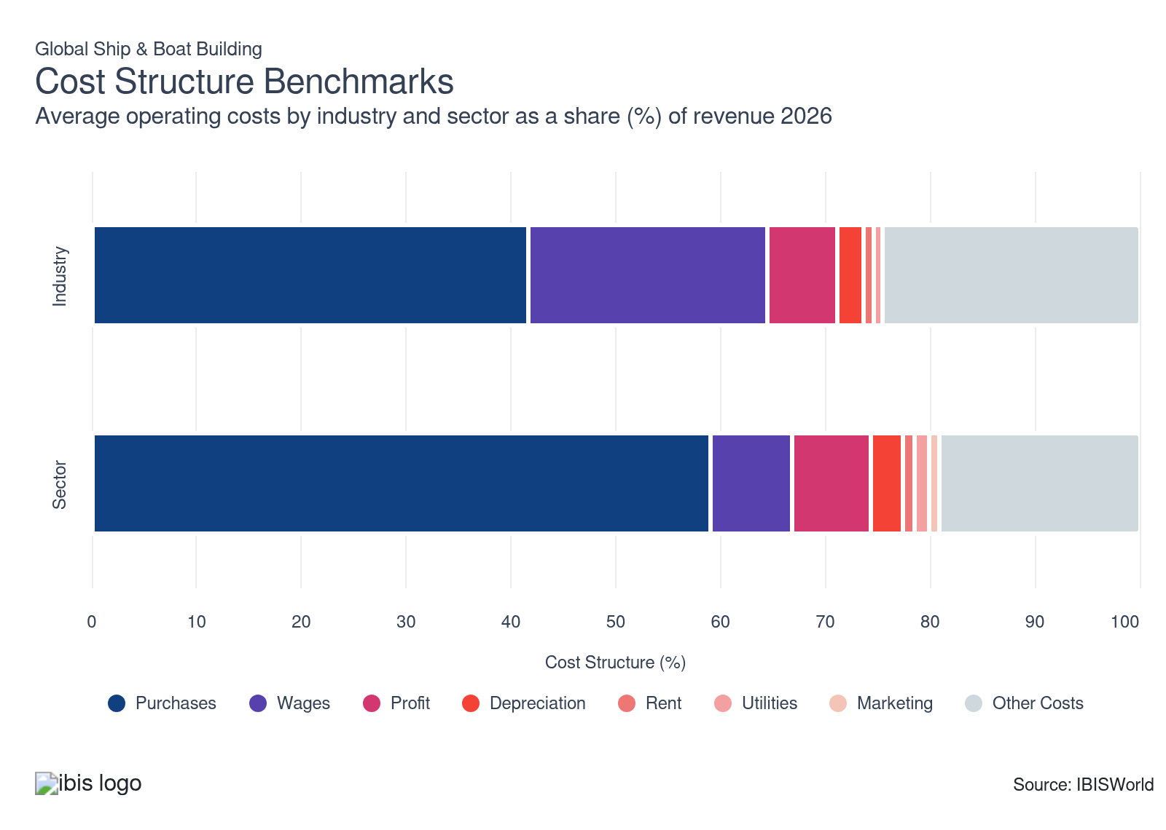
Chart displays current year only in the PDF version of this report. You can view and download chart for all other years associated with this industry on my.ibisworld.com.

What trends impact industry costs?

Shipbuilders continue to face supply chain and trade volatility
- Purchases represent the largest cost for shipbuilders. Steel is the primary raw material for hulls and structural components, and its price has been volatile throughout the period. US tariffs on steel and aluminum imports — raised to 50.0% in June 2025 — have pushed up domestic steel prices and redirected excess global supply to non-US markets. Unlike lighter manufacturing industries that can substitute materials when prices spike, shipbuilders have few viable alternatives to steel for large vessel construction.
- Shipbuilders also purchase engines, navigation systems, weaponry and communications equipment, with the specific mix varying by vessel type. Builders working on fixed-price defense contracts have limited ability to renegotiate when input costs rise, while commercial shipbuilders can more readily pass cost increases to buyers.

Shipbuilders rely on skilled labor
- Wages are the second-largest cost for shipbuilders and have declined as a share of revenue through the period. Industry employment has fallen as automation in shipyard assembly processes and the closure of less competitive yards have reduced headcount. Shipbuilding remains more labor-intensive than most heavy manufacturing industries because of the custom nature of each vessel, limiting how far automation can reduce labor needs.
- Competition for skilled workers — welders, marine engineers and project managers with specialized certifications — has intensified as defense spending grows and order books fill. However, the contraction in total headcount has outpaced wage inflation, pulling wages' share of revenue down.

Profit has narrowed as input cost pressures outpace pricing gains
- Profit has declined moderately as a share of revenue over the period. Elevated steel and aluminum costs, combined with delays and overruns on fixed-price US defense contracts, squeezed profits for builders unable to renegotiate terms.
- Larger yards with diversified order books spanning commercial, military and offshore segments have maintained stronger profit than smaller builders reliant on a narrow contract base. The growing share of LNG carriers and specialised vessels in the global order book has supported per-unit pricing, partially offsetting input cost inflation.

Automation investments have moderated depreciation costs
- Depreciation has edged down as a share of revenue through the period. Shipyards have invested in robotic welding, automated cutting systems and digital monitoring tools that improve equipment utilization and extend useful life through predictive maintenance.
- Compared to industries like automotive manufacturing where retooling is frequent, shipyard equipment tends to have longer useful lives, keeping depreciation relatively contained. While new technology adoption accelerates the obsolescence cycle for older equipment, the efficiency gains often offset replacement costs.

Rent is a stable fixed cost for shipbuilders
- Rent has remained steady as a share of revenue through the period. Shipyards require large waterfront facilities with drydocks and berths, which are typically held on long-term leases. This makes rent largely a fixed cost that fluctuates minimally with changes in output, similar to other capital-intensive industries like steel mills and oil refineries that depend on fixed-site infrastructure.
- Some builders rent specialized heavy-lift equipment on a project basis rather than purchasing it outright, providing flexibility for one-off contracts without adding to the capital base.

Utility costs remain a minor share of revenue
- Utilities have declined marginally as a share of revenue through the period. Energy consumption concentrates in welding, painting and heavy machinery operation, but these costs are small relative to the high per-unit value of the vessels being built. Shipbuilding is less energy-intensive per dollar of output than upstream industries like steel production or aluminum smelting that supply its raw materials.
- Rising global energy prices tied to the conflict between the US and Iran in the spring of 2026 may put upward pressure on this cost category in the near term, though shipbuilders have reduced energy costs by batching production processes and investing in more efficient equipment.

Direct contracting keeps marketing costs negligible
- Marketing accounts for the smallest share of revenue among all cost categories and has held steady through the period. Shipbuilders secure contracts through direct negotiations, government procurement processes and competitive bidding rather than consumer-facing advertising. This contrasts sharply with downstream industries like cruise lines and commercial shipping firms that spend heavily on marketing to attract passengers and freight customers.
- Digital marketing through company websites, virtual shipyard tours and industry conference participation has grown but remains a minor expenditure. Most marketing activity is relationship-driven, focused on maintaining connections with defense agencies, shipping companies and offshore energy operators.
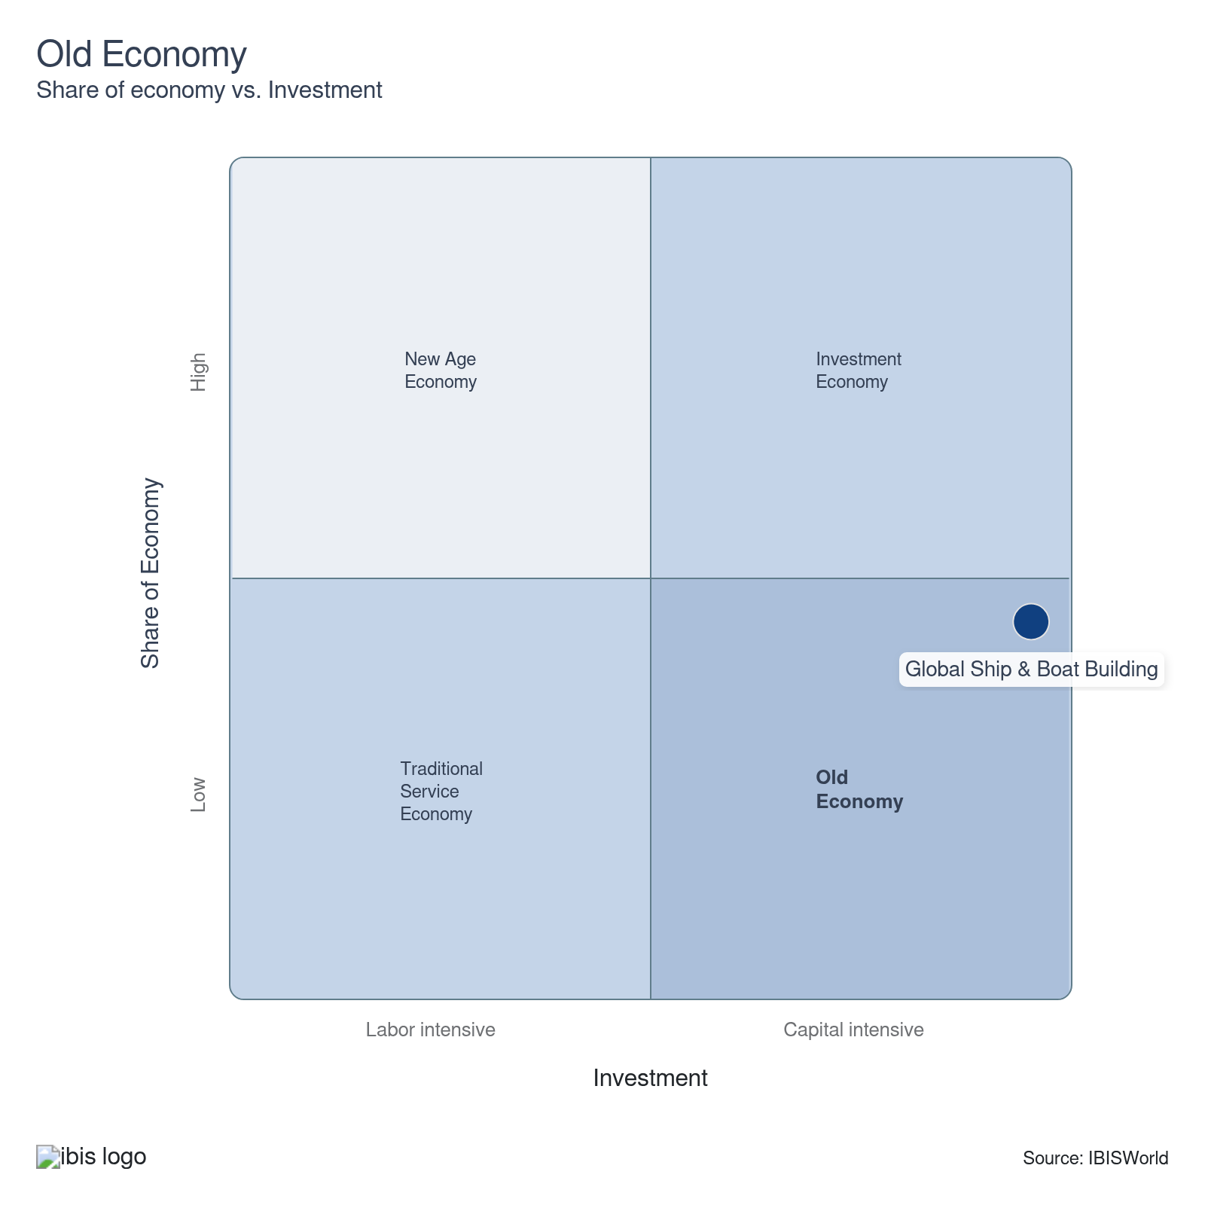

Key Ratios
Year | Revenue per Employee  ($) | Revenue per Enterprise  ($ Million) | Employees per Estab.  (Units) | Employees per Enterprise  (Units) | Average Wage  ($) | Wages/ Revenue  (%) | Estab. per Enterprise  (Units) | IVA/ Revenue  (%) | Imports/ Demand  (%) | Exports/ Revenue  (%)
2005 | 226,145 | 59.2 | 199.5 | 261.8 | 64,923 | 28.7 | 1.3 | 36.6 | 37.8 | 37.8
2006 | 260,564 | 64.3 | 189.3 | 246.8 | 69,872 | 26.8 | 1.3 | 37.4 | 37.2 | 37.2
2007 | 295,599 | 74.3 | 193.4 | 251.4 | 78,993 | 26.7 | 1.3 | 38.6 | 26.3 | 26.3
2008 | 293,128 | 81.7 | 210.2 | 278.9 | 80,854 | 27.6 | 1.3 | 41.8 | 33.1 | 33.1
2009 | 304,596 | 84.7 | 204.8 | 278.1 | 106,416 | 34.9 | 1.4 | 49.9 | 23.7 | 23.7
2010 | 289,252 | 79.8 | 216.5 | 276.0 | 98,350 | 34.0 | 1.3 | 47.1 | 26.3 | 26.3
2011 | 345,880 | 81.7 | 187.6 | 236.3 | 95,049 | 27.5 | 1.3 | 40.7 | 20.5 | 20.5
2012 | 329,118 | 67.8 | 161.0 | 206.1 | 90,554 | 27.5 | 1.3 | 40.8 | 20.8 | 20.8
2013 | 320,637 | 50.5 | 136.7 | 157.5 | 87,542 | 27.3 | 1.2 | 40.5 | 22.7 | 22.7
2014 | 350,674 | 50.3 | 129.6 | 143.6 | 91,593 | 26.1 | 1.1 | 39.6 | 17.2 | 17.2
2015 | 347,908 | 49.8 | 127.0 | 143.2 | 94,707 | 27.2 | 1.1 | 41.2 | 18.0 | 18.0
2016 | 379,140 | 73.9 | 139.3 | 195.0 | 96,726 | 25.5 | 1.4 | 40.5 | 18.0 | 18.0
2017 | 353,849 | 76.1 | 167.5 | 215.2 | 95,083 | 26.9 | 1.3 | 42.1 | 23.8 | 23.8
2018 | 306,274 | 72.3 | 159.4 | 236.0 | 92,405 | 30.2 | 1.5 | 43.7 | 25.4 | 25.4
2019 | 296,711 | 63.9 | 150.3 | 215.3 | 94,637 | 31.9 | 1.4 | 44.1 | 27.8 | 27.8
2020 | 328,642 | 69.0 | 142.9 | 209.9 | 97,600 | 29.7 | 1.5 | 40.1 | 23.4 | 23.4
2021 | 341,628 | 69.7 | 136.9 | 204.1 | 96,686 | 28.3 | 1.5 | 38.3 | 24.9 | 24.9
2022 | 361,471 | 64.9 | 124.9 | 179.6 | 91,473 | 25.3 | 1.4 | 35.7 | 23.6 | 23.6
2023 | 377,039 | 56.5 | 119.6 | 149.8 | 89,936 | 23.9 | 1.3 | 34.4 | 22.9 | 22.9
2024 | 384,641 | 58.1 | 120.6 | 151.1 | 90,300 | 23.5 | 1.3 | 34.2 | 22.5 | 22.5
2025 | 390,616 | 58.8 | 120.2 | 150.6 | 90,581 | 23.2 | 1.3 | 34.1 | 22.0 | 22.0
2026 | 395,867 | 59.3 | 119.8 | 149.9 | 90,822 | 22.9 | 1.3 | 34.1 | 21.4 | 21.4
2027 | 400,693 | 59.9 | 119.7 | 149.5 | 91,044 | 22.7 | 1.2 | 34.0 | 21.5 | 21.5
2028 | 404,539 | 60.3 | 119.6 | 149.1 | 91,219 | 22.5 | 1.2 | 33.8 | 21.5 | 21.5
2029 | 407,793 | 60.7 | 119.6 | 148.8 | 91,365 | 22.4 | 1.2 | 33.7 | 21.5 | 21.5
2030 | 410,659 | 61.3 | 120.0 | 149.2 | 91,494 | 22.3 | 1.2 | 33.6 | 21.6 | 21.6
2031 | 412,232 | 61.7 | 120.5 | 149.8 | 91,564 | 22.2 | 1.2 | 33.6 | 21.6 | 21.6
2032 | 411,169 | 61.4 | 120.2 | 149.4 | 91,517 | 22.3 | 1.2 | 33.6 | 21.6 | 21.6
*Figures are inflation adjusted to 2026
*Figures are inflation adjusted to 2026

10. Key Statistics
https://my.ibisworld.com/gl/en/industry/C2541-GL/key-statistics

Industry Data

Values
Year | Revenue  ($ Million) | IVA  ($ Million) | Estab.  (Units) | Enterprises  (Units) | Employment  (Units) | Exports  ($ Million) | Imports  ($ Million) | Wages  ($ Million)
2005 | 120,617.8 | 44,156.4 | 2,674 | 2,037 | 533,364 | 45,617.8 | 45,617.8 | 34,627.7
2006 | 151,211.9 | 56,577.3 | 3,065 | 2,351 | 580,326 | 56,182.6 | 56,182.6 | 40,548.8
2007 | 196,111.5 | 75,678.7 | 3,430 | 2,639 | 663,437 | 51,635.4 | 51,635.4 | 52,406.7
2008 | 260,773.8 | 109,133.7 | 4,232 | 3,190 | 889,624 | 86,246.2 | 86,246.2 | 71,930.0
2009 | 297,482.1 | 148,453.7 | 4,769 | 3,512 | 976,645 | 70,447.5 | 70,447.5 | 103,930.7
2010 | 335,401.0 | 158,090.3 | 5,356 | 4,201 | 1,159,544 | 88,189.2 | 88,189.2 | 114,041.0
2011 | 383,958.8 | 156,196.0 | 5,917 | 4,697 | 1,110,092 | 78,521.8 | 78,521.8 | 105,513.4
2012 | 350,802.1 | 143,176.6 | 6,620 | 5,172 | 1,065,885 | 72,792.7 | 72,792.7 | 96,520.0
2013 | 329,169.7 | 133,212.9 | 7,510 | 6,517 | 1,026,613 | 74,785.6 | 74,785.6 | 89,872.1
2014 | 337,829.8 | 133,620.4 | 7,432 | 6,710 | 963,374 | 58,179.2 | 58,179.2 | 88,238.5
2015 | 331,755.6 | 136,645.4 | 7,508 | 6,658 | 953,573 | 59,775.9 | 59,775.9 | 90,310.2
2016 | 331,775.9 | 134,409.3 | 6,280 | 4,487 | 875,076 | 59,748.5 | 59,748.5 | 84,642.9
2017 | 284,753.6 | 119,988.9 | 4,805 | 3,740 | 804,732 | 67,873.7 | 67,873.7 | 76,516.5
2018 | 234,344.9 | 102,339.9 | 4,800 | 3,242 | 765,148 | 59,548.1 | 59,548.1 | 70,703.4
2019 | 211,018.2 | 93,119.7 | 4,733 | 3,303 | 711,191 | 58,629.3 | 58,629.3 | 67,305.2
2020 | 218,230.7 | 87,433.5 | 4,648 | 3,163 | 664,037 | 51,119.0 | 51,119.0 | 64,810.3
2021 | 215,005.4 | 82,350.3 | 4,597 | 3,084 | 629,355 | 53,443.5 | 53,443.5 | 60,849.8
2022 | 213,896.5 | 76,306.5 | 4,738 | 3,295 | 591,739 | 50,399.4 | 50,399.4 | 54,128.2
2023 | 214,466.3 | 73,747.0 | 4,757 | 3,796 | 568,818 | 49,189.8 | 49,189.8 | 51,157.0
2024 | 217,068.2 | 74,337.2 | 4,680 | 3,734 | 564,340 | 48,788.0 | 48,788.0 | 50,960.1
2025 | 220,638.2 | 75,164.0 | 4,701 | 3,750 | 564,847 | 48,571.7 | 48,571.7 | 51,164.6
2026 | 223,897.5 | 76,382.0 | 4,721 | 3,773 | 565,588 | 47,916.8 | 47,916.8 | 51,368.1
2027 | 228,007.9 | 77,576.4 | 4,755 | 3,805 | 569,034 | 48,960.8 | 48,960.8 | 51,807.0
2028 | 232,131.0 | 78,554.3 | 4,799 | 3,848 | 573,816 | 49,913.1 | 49,913.1 | 52,342.7
2029 | 236,717.1 | 79,757.0 | 4,855 | 3,901 | 580,484 | 50,967.5 | 50,967.5 | 53,036.1
2030 | 241,920.5 | 81,298.7 | 4,908 | 3,949 | 589,103 | 52,157.7 | 52,157.7 | 53,899.3
2031 | 246,025.3 | 82,646.3 | 4,954 | 3,985 | 596,813 | 53,113.8 | 53,113.8 | 54,646.5
2032 | 246,025.3 | 82,752.5 | 4,979 | 4,006 | 598,356 | 53,185.0 | 53,185.0 | 54,759.6

*Figures are inflation adjusted to 2026

Annual Change
Year | Revenue  % | IVA  % | Estab.  % | Enterprises  % | Employment  % | Exports  % | Imports  % | Wages  %
2005 | N/A | N/A | N/A | N/A | N/A | N/A | N/A | N/A
2006 | 25.4 | 28.1 | 14.6 | 15.4 | 8.8 | 23.2 | 23.2 | 17.1
2007 | 29.7 | 33.8 | 11.9 | 12.3 | 14.3 | -8.1 | -8.1 | 29.2
2008 | 33.0 | 44.2 | 23.4 | 20.9 | 34.1 | 67.0 | 67.0 | 37.3
2009 | 14.1 | 36.0 | 12.7 | 10.1 | 9.8 | -18.3 | -18.3 | 44.5
2010 | 12.7 | 6.5 | 12.3 | 19.6 | 18.7 | 25.2 | 25.2 | 9.7
2011 | 14.5 | -1.2 | 10.5 | 11.8 | -4.3 | -11.0 | -11.0 | -7.5
2012 | -8.6 | -8.3 | 11.9 | 10.1 | -4.0 | -7.3 | -7.3 | -8.5
2013 | -6.2 | -7.0 | 13.4 | 26.0 | -3.7 | 2.7 | 2.7 | -6.9
2014 | 2.6 | 0.3 | -1.0 | 3.0 | -6.2 | -22.2 | -22.2 | -1.8
2015 | -1.8 | 2.3 | 1.0 | -0.8 | -1.0 | 2.7 | 2.7 | 2.3
2016 | 0.0 | -1.6 | -16.4 | -32.6 | -8.2 | 0.0 | 0.0 | -6.3
2017 | -14.2 | -10.7 | -23.5 | -16.6 | -8.0 | 13.6 | 13.6 | -9.6
2018 | -17.7 | -14.7 | -0.1 | -13.3 | -4.9 | -12.3 | -12.3 | -7.6
2019 | -10.0 | -9.0 | -1.4 | 1.9 | -7.1 | -1.5 | -1.5 | -4.8
2020 | 3.4 | -6.1 | -1.8 | -4.2 | -6.6 | -12.8 | -12.8 | -3.7
2021 | -1.5 | -5.8 | -1.1 | -2.5 | -5.2 | 4.5 | 4.5 | -6.1
2022 | -0.5 | -7.3 | 3.1 | 6.8 | -6.0 | -5.7 | -5.7 | -11.0
2023 | 0.3 | -3.4 | 0.4 | 15.2 | -3.9 | -2.4 | -2.4 | -5.5
2024 | 1.2 | 0.8 | -1.6 | -1.6 | -0.8 | -0.8 | -0.8 | -0.4
2025 | 1.6 | 1.1 | 0.4 | 0.4 | 0.1 | -0.4 | -0.4 | 0.4
2026 | 1.5 | 1.6 | 0.4 | 0.6 | 0.1 | -1.3 | -1.3 | 0.4
2027 | 1.8 | 1.6 | 0.7 | 0.8 | 0.6 | 2.2 | 2.2 | 0.9
2028 | 1.8 | 1.3 | 0.9 | 1.1 | 0.8 | 1.9 | 1.9 | 1.0
2029 | 2.0 | 1.5 | 1.2 | 1.4 | 1.2 | 2.1 | 2.1 | 1.3
2030 | 2.2 | 1.9 | 1.1 | 1.2 | 1.5 | 2.3 | 2.3 | 1.6
2031 | 1.7 | 1.7 | 0.9 | 0.9 | 1.3 | 1.8 | 1.8 | 1.4
2032 | 0.0 | 0.1 | 0.5 | 0.5 | 0.3 | 0.1 | 0.1 | 0.2

*Figures are inflation adjusted to 2026

DISCLAIMER
This product has been supplied by IBISWorld Inc. (‘IBISWorld’) solely for use by its authorized licenses strictly in accordance with their license agreements with IBISWorld. IBISWorld makes no representation to any other person with regard to the completeness or accuracy of the data or information contained herein, and it accepts no responsibility and disclaims all liability (save for liability which cannot be lawfully disclaimed) for loss or damage whatsoever suffered or incurred by any other person resulting from the use of, or reliance upon, the data or information contained herein. Copyright in this publication is owned by IBISWorld Inc. The publication is sold on the basis that the purchaser agrees not to copy the material contained within it for other than the purchasers own purposes. In the event that the purchaser uses or quotes from the material in this publication – in papers, reports, or opinions prepared for any other person – it is agreed that it will be sourced to: IBISWorld Inc.

